A Data Mining approach on the analysis of Road Safety in
Great Britain

Dissertation submitted in part fulfilment of the
requirements for the degree of

M.Sc. in Data Analytics

at



Submitted by

Vignesh Muthumani
(Id: 10385771)

on

16/12/2018

under the guidance of the supervisor,

Dr. Shahram Azizi Sazi

Declaration
I, Vignesh Muthumani, declare that this research is my original work and that it has never been presented to any institution or university for the award of Degree or Diploma. In addition, I have referenced correctly all literature and sources used in this work and this work is fully compliant with the Dublin Business School’s academic honesty policy.

Signed by: Vignesh Muthumani
Date: 16/12/2018

Acknowledgement
I would like to express my sincere thanks to my dear supervisor, Dr. Shahram Azizi Sazi for his extreme support and involvement in helping me throughout the research project. His guidance, support and motivation helped me in completing a fully satisfied research project successfully within this span of three months. I would also like to thank my friends and family for their incredible concern, support and motivation during this crucial period.
Abstract:
Road Traffic Accidents (RTAs) are a serious concern in today’s world as their numbers keep escalating by each year due to the increase in the use of road transport and several other factors. Although this is a worldwide concern, they pose a serious threat in well-developed nations such as Great Britain (GB) as RTAs rank among the leading causes of fatalities and injuries. This is still a challenge for the transportation governing agencies to take appropriate precautions as the RTA data collected are huge, multi-dimensional and heterogeneous. Moreover, the data may be incomplete and contain erroneous values, which makes the data analysis a daunting task. The target data for this study was collected by the Department for Transport, GB. Several data mining techniques such as handling an imbalanced dataset, factor reduction and prediction algorithms such as Naïve Bayes, Decision Tree, Random Forest, Logistic Regression, Support Vector Machines (SVM) are carried out to perform an effective data analysis that could potentially support the transport department in devising better precautional measures to minimize the road accident occurrences in Great Britain. Moreover, the idea of chaining two different algorithms is attempted by identifying the significant attributes through Random Forest technique and feeding them as input to other algorithms. In addition, the key factors that influence these road collisions are identified and presented.

Table of Contents
1. Introduction 7
1.1 Research Question 7
1.2 About the primary research material 8
1.3 Aims and Objectives 8
2. Literature Review 9
2.1 Introduction 9
2.2 Road system’s defects and its impacts 9
2.3 Factors considered while modelling road traffic accidents 10
2.4 Supervised classification algorithms 10
2.5 Comparison of Road Traffic Accidents modelling and identified Gaps 12
2.6 Conclusion 13
3. Methodology 13
3.1 Introduction 13
3.2 CRISP-DM methodology 13
3.3 Process flow 21
3.4 Architectural and technical design 22
3.5 Conclusion 22
4. Implementation 22
4.1 Introduction 22
4.2 Data Preparation 23
4.2.1 Treating the missing values 23
4.2.2 Attribute selection 24
4.2.3 Treating the class of variables 24
4.2.4 Renaming factor variables 25
4.2.5 Binning factor variables 26
4.2.6 Handling imbalanced dataset 28
4.3 Data exploration 28
4.3.1 Removal of a highly correlated variable 33
4.4 Data modelling 34
4.4.1 Implementation, evaluation and results of Decision Tree 34
4.4.2 Implementation, evaluation and results of Naïve Bayes 36
4.4.3 Implementation, evaluation and results of Logistic Regression 37
4.4.4 Implementation, evaluation and results of Support Vector Machines 38
4.4.5 Implementation, evaluation and results of Random Forest 39
4.4.5.1 Identifying the significant variables from random forest model 40
4.4.5.2 Implementation of the revised RF model with significant attributes 41
4.5 Data evaluation 42
4.5.1 Evaluation based on the accuracy of each model 42
4.5.2 Evaluation based on the ROC curve of each model 43
4.5.3 Comparison of the performance of models under various split ratios 44
4.5.4 Summary 44
4.6 Data Visualization 45
5. Conclusion and future work 49
6. References 51
7. Appendix 54

1. Introduction:
Road Traffic Accidents (RTAs) are one of the primary reasons of death in today’s world as it ranks as the 10th leading cause of death globally according to World Health Organization (WHO). Based on the current trends of road traffic accidents, it further predicts that it could rank up to the 7th spot for leading cause of deaths by 2030 (Jackson & Cracknell, 2018). The 2030 Agenda for Sustainable Development has set an ambitious target of halving the global number of deaths and injuries from road traffic crashes by 2020, as currently it is estimated that approximately 1.35 million people die due to road traffic accidents every year (data.gov.uk, 2018). World Health Organization’s (WHO) study shows that in most cases the casualties are in the age group of 5-29 years, while half of this population that die in the road accidents are the vulnerable road users such as pedestrians, cyclists, and motorcyclists. Especially the developing nations account for 93% of world’s fatalities on roads, though these nations have 60% of world’s vehicles. As a result, these road traffic mishaps cost 3% of GDP (Gross Domestic Product) to most of the countries (data.gov.uk, 2018). In 2017, the road accidents in Great Britain had resulted in 2,823 fatalities with an estimation of 4% increase to that of previous year (data.gov.uk, 2018). According to (Beshah & Hill, 2010), several factors such as the road type, road surface conditions, weather conditions, light conditions, time of the day, etc. contribute a lot to determine the severity of road accidents. By analyzing these factors and making effective predictions using data mining techniques, proper precautional measures can be taken in minimizing the severity of these road traffic accidents significantly.

1.1 Research Question:
“How can the occurrences of road traffic accidents of high severity on Great Britain roads be reduced using classification modelling techniques (Decision Trees, Random Forest, Naïve Bayes, Logistic Regression, Support Vector Machines)?”

Sub-RQ: “Would chaining the Random Forest technique with another classification algorithm yield better results in prediction?”

Justification: Previous researches show that the predictions were done based on the road and weather conditions and other environment related factors. With data insufficiency, information of casualties and vehicles weren’t considered for prediction of the severity of road traffic accidents. But now that the data has been updated in the data.gov.uk and made available for the public, this research project will also make use of all other potential attributes such as driver information, vehicle information, etc. to determine the severity of road traffic accidents in Great Britain more efficiently.

1.2 About the dataset:
This study focuses on the road traffic accidents in Great Britain during 2017. The following three datasets were used to conduct this research and were obtained from the data.gov.uk (data.gov.uk, 2018).

Accidents.csv
Casualties.csv
Vehicles.csv
Data.csv

Table 1: Merging three different datasets into one

(Table 1) demonstrates that the three datasets ‘Accidents’, ‘Casualties’, and ‘Vehicles’ were merged together into one dataset that is used for this study’s data analysis and modelling. The merged dataset contains 170,993 observations and 68 variables. The dataset does not only possess information about the road conditions, weather conditions, light conditions, and severity of the accident, but also contains the information about the vehicles involved (including their make and model) and the information about the consequential casualties. The target variable for the prediction in this study is the attribute, ‘Accident Severity’, which is a factor variable that contains three levels, ‘Fatal’, ‘Serious’, and ‘Slight’. Cases where the severity was fatal/serious account for the deaths and severe injuries, while the other 67 independent variables contribute information for an effective prediction of the dependent (target) variable.

1.3 Aims and Objectives:
The aims and objectives of this research are as follows,
- Objective A: To critically review the work accomplished in the area of road traffic accidents in Great Britain and identify the gaps in the literature.
- Objective B: To identify the key principal components that have a major impact on the road traffic accidents.
- Objective C: To demonstrate the ways of handling an imbalanced data.
- Objective D: To implement and evaluate the following classification models and assess their results to identify the most effective prediction algorithm
  - Naïve Bayes
  - Support Vector Machines
  - Random Forest
  - Logistic Regression
  - Decision Tree
- Objective E: To experiment the idea of chaining two algorithms by identifying the significant attributes of the data using Random Forest technique and feeding the significant ones as input to other classification techniques to identify if it yields better results than the existing models.
2. Literature Review
2.1 Introduction:
According to (Gopalakrishnan, 2012), road traffic accidents (RTAs) are one of the reasons for serious global health issues due to the increase in the motorization in the past few years. Although motorization is proven to be a comfortable and economical mode of transportation, people pay the price for its vulnerability. Several studies by (Kabeer, 2016), (Atnafu & Kaur, 2017) have been carried out to identify the factors that influence these road accidents and steps to reduce its occurrences and lower its severity. Factors related to road and environment like road separation, road orientation, road surface, weather conditions, light conditions (Beshah & Hill, 2010) have a major role in the severity of the road traffic accidents. Data mining techniques have been used to predict the severity of the accidents using machine learning classification algorithms such as Decision tree, random forest, Naive Bayes (Priyanka & Sathiyakumari, 2014), (Kabeer, 2016). In the below sections, various factors that influence these road traffic accidents are discussed.
2.2 Road system’s defects and its impacts:
Defects in the road system is one of the key factors that can’t be ignored as it results in road traffic accidents. According to (Esmaeili, et al., 2012), there are various defects in the road system such as insufficient road width, traffic signs, road surface, slope of the road, road curves, and road lighting could lead to road traffic accidents. Further, (Gopalakrishnan, 2012) adds that missing road safety signs, no footpaths, no pedestrian crossings, missing designated lanes are part of dangerous road conditions for the drivers as well as for the vulnerable road users. Majority of the road accidents occur on the roads in the rural areas where the road system has a two-lane or two-way road (Kashani & Mohaymany, 2011). In Iran, 70% of the accidents have occurred on the rural roads where the two-lane rural road consists of the 30% of the total Iran road network. Comparatively, the occurrences of accidents on the urban roads are less than the rural roads. In England, about 3,500 people are killed every year due to road traffic accidents (Anderson, 2009). As per (Quddus, et al., 2009), increase in the traffic congestion can enhance the road safety, however, on the other hand he states that it can lead to financial loss to the country. Traffic violations such as over speeding, drunk driving, driver not using protective gears can also result in road accidents (Zhang, et al., 2013). According to the (Ghomi, et al., 2017), the number of incidents at the highway-railway grade crossing are high due to the violation of the rules by the people. The number of fatalities is high during crossing than that of people stuck on the railway tracks.

2.3 Factors considered while modelling road traffic accidents:
Road traffic accidents involves vehicles along with the presence of some other factors such as road, environment, vehicle or driver-related terms (Theofilatos, et al., 2012), (Ghomi, et al., 2017), (Yannis, et al., 2005) that have major influence in the road traffic accidents. According to (Vorko-Jovic, et al., 2006), to have effective road accident prevention, it is necessary to find the most likely factors that contribute in the road accidents. Earlier due to insufficient data, research was done only using road and environment related factors like road surface, orientation, urban or rural area, speed limit, light condition and weather conditions (Beshah & Hill, 2010), (Mahajan & Kaur, 2016). The use of different factors like human, vehicle, road and environment-related have been taken into consideration by (Zhang, et al., 2013) to improvise the prediction model. The brief description of all the parent factors and their sub-factors involved in road traffic accident is given by (Tian, et al., 2010). According to the author every parent factor like road, environment, vehicle and driver are divided into number of sub-factors. Each sub-factor providing the in-depth details related to their parent factor. The explanation of the factors is provided in the tree structure where the leaf node provides the minute details of the main factor. For example, the driver related factor is divided into short and long-term factor, which is further divided into physiological and mental factor. The author (Shanthi & Ramani, 2012) and (Ghomi, et al., 2017) have made use of factors like gender, age of driver, type of vehicle, alcohol test along with the road and environment-related factors to make the prediction more effective.

2.4 Supervised classification algorithms:
Classification algorithm is used to predict the data by building the model using the method of data analysis (Atnafu & Kaur, 2017). Based on the target variable the different classification algorithms are used. According to (Shanthi & Ramani, 2012), classification algorithm is used when there is large amount of data that needs to be classified to get exciting patterns. Classification process consist of two stages, building the model and prediction of the future data (Patel & Mistry, 2015). The model building stage makes use of any classification algorithm while the prediction stage makes use of the future data to provide interesting patterns. As per (Ahlawat & Suri, 2016) predefined set of classes are used to classify the future data in classification process. According to the author (Priyanka & Sathiyakumari, 2014) and (Tesema, et al., 2005) classification is used to define single variable of significance in a model while clustering is used to establish relationship between different variables in given data-set. Below is the review of different algorithms that are used in this research project.
- Decision tree is the most commonly used and well-known algorithms for the classification process (Chong, et al., 2005). Easy to understand, generate rules and reduce the complexity of the problem are some of the features of decision tree algorithm (Patel & Mistry, 2015). According to (Kashani & Mohaymany, 2011), if the decision tree is used for nominal target variable then it is called classification tree and if the tree is used for continuous variable then it is called regression tree. Decision tree uses top-down recursive approach to perform the classification (Ahlawat & Suri, 2016). The author (Mahajan & Kaur, 2016) has explained two main concepts entropy and information gain and have used them in the ID3 and C4.5 algorithms. Entropy is randomness used to find homogeneity in the data while information gain is the splitting method used in entropy. (Atnafu & Kaur, 2017) has used the advanced version of ID3 decision tree i.e. J48 which determines the target value based on the attribute value. The author (Beshah & Hill, 2010) has used WEKA explorer to build decision tree while Kabeer (2016) has used rapid miner tool to build decision tree.
- Random forest algorithm is used for both classification and regression models (Patel, 2010). Random forest is an enhancement over decision tree model. This model consists of forest of trees where the input is assigned to each tree in the forest and the output generated from the forest of trees determine the accuracy of the algorithm. Significant variables in the data-set can be found using random forest algorithm. As per (Datla, 2015), increase in the variable results in stronger forest and decrease in the variable results in poor forest for classification. Random forest is efficient and general-purpose algorithm used in different sectors like banking, medical etc. According to (Li, et al., 2017) performance of random forest is more than decision tree, naive bayes and adaboostM1 classifier.
- Support Vector Machines algorithm is also one of the supervised machine learning algorithms that is used for both classification analysis and regression analysis. However, it is widely used for classification purposes rather than regression. It functions by plotting all the datapoints in a multi-dimensional space. The number of dimensions for this space is determined by the number of attributes the dataset has. Then it involves in finding the hyper-plane between the plotted data points in the multi-dimensional area that separates two major classes on either side of the planes. The hyper plane that distinguishes the classes is termed as the support vector machine while the coordinates of it are termed as support vectors (Huang, 2017). Depending on the type of dataset, different kernels can be implemented for better efficiency of the model in finding the effective hyper plane. Kernels such as linear, radial, polynomial, etc. can be used to identify the perfect the hyper plane that gives the best accuracy.
- Logistic Regression is a popularly used statistical model that is mainly used for supervised classification techniques. It was devised by David Cox in 1958 (Zekić-Sušac, et al., 2016). It consists of three types such as binary (for binary outcomes), multinomial (for multiple classes), and ordinal (for categories that are ordered). The model functions by predicting the dependent variable/target variable that’s a binary variable with two outcomes based on several independent variables that can either be numeric or categorical with classes. It functions with the help of logit function, where it possesses beta intercept and each variable’s respective beta coefficients.
- Naive Bayes is an effective classification algorithm widely used in road accident dataset (Atnafu & Kaur, 2017). It uses Bayesian theorem to predict the class probabilities. Classification and prediction of the variable is done on the assumption of independence between the variables. (Beshah & Hill, 2010) has used WEKA explorer to determine the accuracy and has achieved 79.9% accuracy. Author (Zong, et al., 2013) has used Bayesian network for accident severity modelling because of the graphical model that determines the variables and their dependencies. Bayesian theorem works, based on belief and former experience. Easy to implement, computation and support to numeric and textual data are some of the features of naive bayes (Patel & Mistry, 2015). The following tables shows the comparison of reviews of different classification algorithms used in road traffic accidents by different authors.
Author | Model | Accuracy (%)
(Datla, 2015) | Random Forest | 81.34
(Beshah & Hill, 2010) | KNN | 80.81
(Kabeer, 2016) | Bayesian Boosting | 78.03
(Tavakoli Kashani, et al., 2011) | CART | 51.27
(Tesema, et al., 2005) | Decision Tree | 79.83

2.5 Comparison of Road Traffic Accidents Modelling and
Identified Gaps:
Due to increase in road traffic accidents different researches have been carried out to lower the number of casualties. (Atnafu & Kaur, 2017) has proposed a model to lower the number of road accidents in India using data mining techniques. Author (Vorko-Jovic, et al., 2006) has determined different risk factors that have serious effect on road transport to lower the road accidents in urban area. Violation of traffic rules and the risk associated with it is briefly explained by (Zhang, et al., 2013). Even though many researches have been done regarding the road traffic accidents, but very few authors have considered the factors like driver and vehicle-related to build the model. If these gaps are taken into consideration, the model will provide more influential results to lower the road traffic accidents.

2.6 Conclusion:
The candidate concludes that CRISP-DM methodology is used throughout the research project. The process flow diagram shows the stages in which the project will implement starting from dataset to creating dashboard in tableau. Finally, the three-tier architecture design shows the tools and techniques used in client layer, business layer and technical layer.

3. Methodology:
3.1 Introduction:
This Chapter presents the scientific methods and techniques used in this project. In addition, a road traffic process flow diagram is designed, and architectural and technical design of the implementation and evaluation of prediction models is presented. Furthermore, the cross-industry standard for data mining (CRISP-DM) approach is modified and used to guide the candidate during the implementation.

3.2 CRISP-DM methodology:
The candidate has adopted Cross-industry Standard Process for Data Mining (CRISP-DM) throughout the research project. Based on the polls of the KDNuggets, CRISP-DM is one of the popular methodologies that comes with six different phases. The phases are business understanding, data understanding, data preparation, modelling, evaluation and deployment. According to (Achmad, et al., 2016) CRISP-DM is the modified version of the KDD process model and is the industry standard for the knowledge discovery projects. The following (figure 1) shows the modified CRISP-DM methodology.
Figure 1: CRISP-DM Methodology
- Phase-1 Business Understanding: In this project the first phase involves performing a critical review of road traffic accidents occurrences in Great Britain. The main objective is to support transport authorities in improvising the road systems.
- Phase-2 Data Understanding: This phase consists of data gathering and exploration. Here the data is gathered from government data repository of Great Britain Data (data.gov.uk, 2018). The repository consists of three files relating to accidents, casualties and vehicles in the .csv format, which are merged together into one for data analysis. The reasons for these three files to be merged together are to include as much of information as possible for an effective analysis. The merged dataset comprises of 170,993 observations and 68 variables including the target variable, ‘accident severity’. The 68 attributes are as follows.
  - Accident index – Reference number for each of the accident occurred. The information across all three datasets are merged together based on their accident index
  - Vehicle_Reference – Reference number for the information about vehicles.
  - Location_Easting_OSGR – Geographic cartesian coordinates. Easting refers to the eastward-measured distance (x-coordinate)
  - Location_Northing_OSGR – Geographic cartesian coordinates. Northing refers to the northward-measured distance (y-coordinate)
  - Longitude – Longitudinal coordinate of the place of accident occurrence
  - Latitude – Latitudinal coordinate of the place of accident occurrence
  - Police_Force – Types of police forces in Great Britain. Consists of 51 classes of police for several counties.
  - Accident_Severity – Severity of the accidents occurred. This is the target variable for this study. It consists of three classes such as slight, severe and fatal.
  - Number_of_Vehicles – It denotes the number of vehicles involved in the accident.
  - Number_of_Casualties – It denotes the number of casualties involved in the accident.
  - Date – It denotes the date on which the accident occurred.
  - Day_of_Week – It denotes the day of the week in which accident occurred.
  - Time – It denotes the time of the day in which accident occurred.
  - Local_Authority_.District. – It denotes the concerned authority for the respective district in which accident occurred. Variable has 416 classes comprising of all the districts in Great Britain
  - Local_Authority_.Highway. – It denotes the concerned authority for the respective highways in which accident occurred. Variable has 207 classes comprising of all the highways in Great Britain
  - 1st_Road_Class – It denotes the class of the 1st road
  - 1st_Road_Number – It denotes the respective number of the 1st road
  - Road_Type – It denotes the type of the road. It has 8 classes which includes Roundabout, One-way street, Dual carriageway, Single carriageway, Slip road, Unknown, One way street/Slip road, and Data missing or out of range.
  - Speed_limit – It denotes the speed limit set for the roads in which the accidents occurred.
  - Junction_Detail – It contains information about the respective junctions in which accidents occurred. It contains 10 classes which includes Not at junction or within 20 metres, Roundabout, Mini-roundabout, T or staggered junction, Slip road, Crossroads, More than 4 arms (not roundabout), Private drive or entrance, Other junction, Data missing or out of range.
  - Junction_Control – It contains information about the respective individual/thing who is in charge of the respective junction in which accidents occurred. It contains 6 classes which includes Not at junction or within 20 metres, Authorised person, Auto traffic signal, Stop sign, Give way or uncontrolled, Data missing or out of range
  - 2nd_Road_Class – It denotes the class of the 2nd road
  - 2nd_Road_Number – It denotes the respective number of the 2nd road
  - Pedestrian_Crossing.Human_Control – It denotes the presence of the pedestrian crossing that are controlled by humans. It contains 4 classes which includes None within 50 metres, Control by school crossing patrol, Control by other authorised person, Data missing or out of range
  - Pedestrian_Crossing.Physical_Facilities – It denotes the presence of the pedestrian crossing that are controlled by physical facilities. It contains 7 classes which include No physical crossing facilities within 50 metres, Zebra, Pelican, puffin, toucan or similar non-junction pedestrian light crossing, Pedestrian phase at traffic signal junction, Footbridge or subway, Central refuge, Data missing or out of range
  - Light_Conditions – It denotes the light conditions during the occurrences of the accidents. It contains 6 classes which include Daylight, Darkness - lights lit, Darkness - lights unlit, Darkness - no lighting, Darkness - lighting unknown, Data missing or out of range
  - Weather_Conditions – It denotes the weather conditions during which the accidents occurred. It contains 10 classes which includes Fine with no high winds, Raining with no high winds, Snowing with no high winds, Fine with high winds, Raining with high winds, Snowing with high winds, Fog or mist, Other, Unknown, Data missing or out of range
  - Road_Surface_Conditions – It denotes the surface conditions of the roads in which the accidents occurred. It contains 7 classes which includes conditions like Wet or damp, Snow, Frost or ice, Flood over 3cm. deep, Oil or diesel, Mud, Data missing or out of range
  - Special_Conditions_at_Site – It denotes if there were any special conditions at the site. It contains 9 classes which includes None, Auto traffic signal – out, Auto signal part defective, Road sign or marking defective or obscured, Roadworks, Road surface defective, Oil or diesel, Mud, Data missing or out of range
  - Carriageway_Hazards – It denotes the hazards in carriageways which consists of 9 classes that include None, Vehicle load on road, Other object on road, Previous accident, Dog on road, Other animal on road, Pedestrian in carriageway - not injured, any animal in carriageway (except ridden horse), Data missing or out of range
  - Urban_or_Rural_Area – It denotes if the place of occurrence of the accident was urban or rural area. It contains 3 classes that includes urban, rural and unallocated.
  - Did_Police_Officer_Attend_Scene_of_Accident – It denotes if any police officer attended the scene of the accident. It consists of three classes which includes yes, no, and No - accident was reported using a self completion form (self rep only).
  - LSOA_of_Accident_Location – LSOA denotes Lower Layer Super Output Area, which is a geographical area. LSOA is a geographic hierarchy that was devised to improve the reporting of small area statistics in Great Britain.
  - Casualty_Reference – Similar to accident index and vehicle index, this denotes the reference numbers for the casualties to access their information.
  - Casualty_Class – Casualty class determines the type of casualty during the accident. It has three classes which includes the driver or rider, passenger, and pedestrian.
  - Sex_of_Casualty – It denotes the gender of the casualty. It contains 3 classes which includes male, female, and Data missing or out of range.
  - Age_of_Casualty – It denotes the age of casualties during the occurrence of the accident.
  - Age_Band_of_Casualty – It denotes the age band of the casualties during the occurrence of the accident. It contains 12 classes which includes the age categories of 0 – 5, 6 – 10, 11 – 15, 16 – 20, 21 – 25, 26 – 35, 36 – 45, 46 – 55, 56 – 65, 66 – 75, Over 75, Data missing or out of range.
  - Casualty_Severity – Similar to the accident severity, it signifies the severity of the casualty which includes the same 3 classes such as slight, severe, fatal.
  - Pedestrian_Location – It denotes the location of the pedestrian when the accident occurred. It contains 12 classes which includes Not a Pedestrian, Crossing on pedestrian crossing facility, Crossing in zig-zag approach lines, Crossing in zig-zag exit lines, Crossing elsewhere within 50m. of pedestrian crossing, In carriageway, crossing elsewhere, On footway or verge, On refuge, central island or central reservation, In centre of carriageway - not on refuge, island or central reservation, In carriageway, not crossing, Unknown or other, Data missing or out of range.
  - Pedestrian_Movement – It denotes the movement of the pedestrians during the occurrence of the accident. It contains 11 classes which includes Not a Pedestrian, Crossing from driver's nearside, Crossing from nearside - masked by parked or stationary vehicle, Crossing from driver's offside, Crossing from offside - masked by parked or stationary vehicle, In carriageway, stationary - not crossing (standing or playing), In carriageway, stationary - not crossing (standing or playing) - masked by parked or stationary vehicle, Walking along in carriageway, facing traffic, Walking along in carriageway, back to traffic, Unknown or other, Data missing or out of range
  - Car_Passenger – It denotes the position of the passengers in the car during the occurrence of the accident. It contains four classes such as Not car passenger, Front seat passenger, Rear seat passenger, Data missing or out of range.
  - Bus_or_Coach_Passenger – It denotes the position of the passengers in the buses or coaches during the occurrence of the accident. It contains 6 classes such as Not a bus or coach passenger, Boarding, Alighting, Standing passenger, Seated passenger, Data missing or out of range
  - Pedestrian_Road_Maintenance_Worker – It denotes if the pedestrian was a road maintenance worker. It consists of 4 classes such as No / Not applicable, Yes, Not Known, Data missing or out of range.
  - Casualty_Type – It denote the type of the casualty. It contains 21 classes which includes Pedestrian, Cyclist, Motorcycle 50cc and under rider or passenger, Motorcycle 125cc and under rider or passenger, Motorcycle over 125cc and up to 500cc rider or passenger, Motorcycle over 500cc rider or passenger, Taxi/Private hire car occupant, Car occupant, Minibus (8 - 16 passenger seats) occupant, Bus or coach occupant (17 or more pass seats), Horse rider, Agricultural vehicle occupant, Tram occupant, Van / Goods vehicle (3.5 tonnes mgw or under) occupant, Goods vehicle (over 3.5t. and under 7.5t.) occupant, Goods vehicle (7.5 tonnes mgw and over) occupant, Mobility scooter rider, Electric motorcycle rider or passenger, Other vehicle occupant, Motorcycle - unknown cc rider or passenger, Goods vehicle (unknown weight) occupant
  - Casualty_Home_Area_Type – It denotes the home area of the casualties. It contains 4 classes such as urban area, small town, rural, missing data
  - Casualty_IMD_Decile – It refers to Index of multiple deprivation of the casualty. It consists of 11 classes on varying levels of deprivation of the casualties from 10-50%
  - Vehicle_Type – It denotes the type of the vehicle involved in the accident. It consists of 21 classes which includes Pedal cycle, Motorcycle 50cc and under, Motorcycle 125cc and under, Motorcycle over 125cc and up to 500cc, Motorcycle over 500cc, Taxi/Private hire car, Car, Minibus (8 - 16 passenger seats), Bus or coach (17 or more pass seats), Ridden horse, Agricultural vehicle, Tram, Van / Goods 3.5 tonnes mgw or under, Goods over 3.5t. and under 7.5t, Goods 7.5 tonnes mgw and over, Mobility scooter, Electric motorcycle, Other vehicle, Motorcycle - unknown cc, Goods vehicle - unknown weight, Data missing or out of range .
  - Towing_and_Articulation – It denotes the towing and articulation of the vehicle involving 7 classes such as No tow/articulation, Articulated vehicle, Double or multiple trailer, Caravan, Single trailer, Other tow, Data missing or out of range
  - Vehicle_Manoeuvre – It denotes the manoeuvring of the vehicle during the accident. It consists of 19 classes such as Reversing, Parked, Waiting to go - held up, Slowing or stopping, Moving off, U-turn, Turning left, Waiting to turn left, Turning right, Waiting to turn right, Changing lane to left, Changing lane to right, Overtaking moving vehicle – offside, Overtaking static vehicle – offside, Overtaking – nearside, Going ahead left-hand bend, Going ahead right-hand bend, Going ahead other, Data missing or out of range
  - Vehicle_Location.Restricted_Lane – It denotes if the vehicle was in a restricted lane. It consists of 12 classes such as On main c'way - not in restricted lane, Tram/Light rail track, Bus lane, Busway (including guided busway), Cycle lane (on main carriageway), Cycleway or shared use footway (not part of main carriageway), On lay-by or hard shoulder, Entering lay-by or hard shoulder, Leaving lay-by or hard shoulder, Footway (pavement), Not on carriageway, Data missing or out of range
  - Junction_Location – It denotes the location of the junction which consists of 10 classes such as Not at or within 20 metres of junction, Approaching junction or waiting/parked at junction approach, Cleared junction or waiting/parked at junction exit, Leaving roundabout, Entering roundabout, Leaving main road, Entering main road, Entering from slip road, Mid Junction - on roundabout or on main road, Data missing or out of range.
  - Skidding_and_Overturning – It denotes if the vehicle was skidded or overturned during the accident. It consists of 7 classes such as None, Skidded, Skidded and overturned, Jackknifed, Jackknifed and overturned, Overturned, Data missing or out of range
  - Hit_Object_in_Carriageway – It denotes if the vehicle hit any objects in the carriageway. It consists of 13 classes that include None, Previous accident, Road works, Parked vehicle, Bridge (roof), Bridge (side), Bollard or refuge, Open door of vehicle, Central island of roundabout, Kerb, Other object, Any animal (except ridden horse), Data missing or out of range
  - Vehicle_Leaving_Carriageway – It denotes the vehicle leaving the cariiageway which consists of 10 classes such as nearside, offside, etc.
  - Hit_Object_off_Carriageway – It denotes if the vehicles hit any objects off the carriageway such as road signs, lampposts, trees, etc. It consists of 13 classes/
  - 1st_Point_of_Impact – It denotes the vehicles 1st point of impact during the accident. It consists of 6 classes such as Did not impact, Front, Back, Offside, Nearside, Data missing or out of range.
  - Was_Vehicle_Left_Hand_Drive. – It denotes if the vehicle was a left hand drive containing 3 classes such as yes, no, and unknown
  - Journey_Purpose_of_Driver – It denotes the journey purpose of the driver. It consists of classes such as Journey as part of work, Commuting to/from work, Taking pupil to/from school, Pupil riding to/from school, Other, Not known, Other/Not known (2005-10), Data missing or out of range
  - Sex_of_Driver – It denotes the gender of the driver under classes such as male, female and unknown
  - Age_of_Driver – It denotes the age of the driver.
  - Age_Band_of_Driver – It denotes the age band of the driver
  - Engine_Capacity_.CC. – It denotes the engine’s displacement capacity of vehicles that involved in accidents
  - Propulsion_Code – It denotes the type of the engine such as petrol, diesel, electric, gas, etc.
  - Age_of_Vehicle – It denotes the age of the vehicle
  - Driver_IMD_Decile – It denotes the IMD decile of the drivers
  - Driver_Home_Area_Type – It denotes the home area of the driver which is urban or rural.
  - Vehicle_IMD_Decile – It denotes the IMD decile for the vehicles.

- Phase-3 Data Preparation: This phase consists of data integration and cleaning. In this research project the three .csv files are integrated together using the merge function performed on RStudio, and the ROSE package is used to handle the imbalanced data set.
- Phase-4 Data Modelling: This phase consists of implementation process which is done using different data mining algorithms i.e. decision tree, random forest, support vector machines, naive bayes and logistic regression algorithms to implement the predictive models.
- Phase-5 Data Evaluation: This phase consists of evaluation of the results of the predictive model. Here the author has used metrics such as accuracy and confusion matrix to determine the best-fit algorithm.
- Phase-6 Data Deployment: This is the last phase of CRISP-DM methodology. In this research project the author has made use of R-studio to deploy the algorithm that provides highest accuracy for building the model and predicting the severity of road traffic accidents in Great Britain. Visualization tools such as Tableau, PowerBI, RapidMiner have been used to show the visual relation between the different variables related to road traffic accidents.
3.3 Process flow:
Figure 2: Process flow diagram
The process flow diagram of the research project is shown in (Figure.2). Data is gathered from road safety data repository, which consists of three files accident.csv (A), casualty.csv (C), and vehicle.csv (V). The three files are combined into a single dataset using the ‘merge’ function executed in RStudio. The ROSE package is used to handle the imbalanced data. The implementation of models is carried out on four algorithms, decision tree (DT), random forest (RF), support vector machines (SVM), logistic regression (LGR) and naive bayes (NB). Furthermore, the results of the models are evaluated to determine the best algorithm based on the accuracy metric and ROC curve. Finally, the data is visualized through data visualization tool like Tableau to find out the relation between the variables present in the dataset.

3.4 Architectural and Technical Design:
Figure 3: Three tier architectural design of RTA

The above (Figure.3) consist of three tier architectural design of road traffic accident. The first tier consists of client layer where the user interface is used to present the results using tableau. The next tier is the business logic layer. Most of the computation and implementation are carried out in this layer. It consists of different algorithms i.e. decision tree, random forest, support vector machines, logistic regression and naive bayes. Finally, the third tier is the data persistent layer which combines dataset using merge function from RStudio. The results from this layer are passed into the business logic layer for further processing and computations.

3.5 Conclusion:
The candidate concludes that CRISP-DM methodology is used throughout the research project. The process flow diagram shows the stages in which the project will implement starting from dataset to creating dashboard in tableau. Finally, the three-tier architecture design shows the tools and techniques used in client layer, business layer and technical layer.

4. Implementation, Evaluation and Results:
4.1 Introduction:
This Chapter comprises of the data preparation stage followed by the data modelling phase. Data preparation stage is considered the most essential part for pruning the data before the data modelling stage to achieve efficient prediction results. The main objective of this research project is conducted in this chapter. The implementation and evaluation of prediction models i.e. Decision Tree, Random Forest, Logistic Regression, Support Vector Machines, and Naïve Bayes are conducted and evaluated using tools such as RStudio, RapidMiner, PowerBI and Tableau.

4.2 Data Preparation:
The data for this research project is gathered from road safety data repository of Great Britain Data (data.gov.uk, 2018). The initial data preparation involves collating the dataset, as the repository consists of three files ‘accident.csv’, ‘casualty.csv’ and ‘vehicle.csv’. Each of these files contains the relevant information about the road accidents, its casualties, and the vehicles respectively. These three files are loaded into the RStudio and merged together into one csv file based on their respective ‘accident index’ using the ‘merge’ function of R programming. As a result, the dataset for the data analysis of this study is obtained.

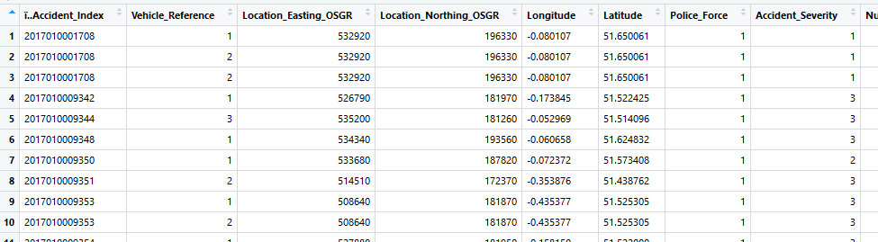
Figure 4: Snapshot of the merged dataset

(Figure 4) displays a snapshot of the merged dataset for our analysis which consists of a total of 68 variables and 170,993 observations.

4.2.1 Treating the missing values:
For an effective analysis and prediction, it is important to treat the missing values in a dataset as it affects the accuracy of prediction during modelling and provides incorrect results. In this dataset, about 50 missing values are there. Since it’s such a meagre value, they are omitted. On further analysis, it was noticed that a lot of instances had ‘-1’ value which was also deemed as missing value as per the data guide obtained from the repository (data.gov.uk, 2018). Hence the instances containing the value, ‘-1’ were replaced with ‘NA’ using the ‘lapply’ function (figure 5) so they can be treated as missing values.
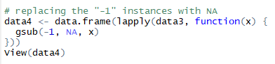
Figure 5: Replacing the ‘-1’ with ‘NA’
This resulted in several instances of missing values in the data. In order to treat these missing values, implementing the ‘mice’ package from RStudio was considered as it substitutes the ‘NA’ instances with the mean value of the other instances in the table. However, the idea was ruled out as it took a lot of time for computation on such a large dataset as it required higher system RAM configuration. Hence, the traditional method of removing the missing values was carried out.

4.2.2 Selecting the desired variables:
Having too many variables on a dataset while modelling makes the process cumbersome and reduces the efficiency of the predictions due to the influence of the irrelevant attributes. The dataset contains 68 attributes of which most of them are irrelevant to the subject area of this study such as registration number of the vehicle, propulsion code, location easting OSGR, location northing OSGR, etc. All the irrelevant attributes were removed and refined to have only the following 19 important key variables (figure 6) that influence the target variable, ‘accident severity’.
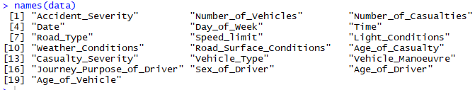
Figure 6: Selected attributes of the whole dataset

4.2.3 Treating the class of variables:
In the existing dataset, the class of several variables were incorrect and were given as factors by default as shown in (figure 7).
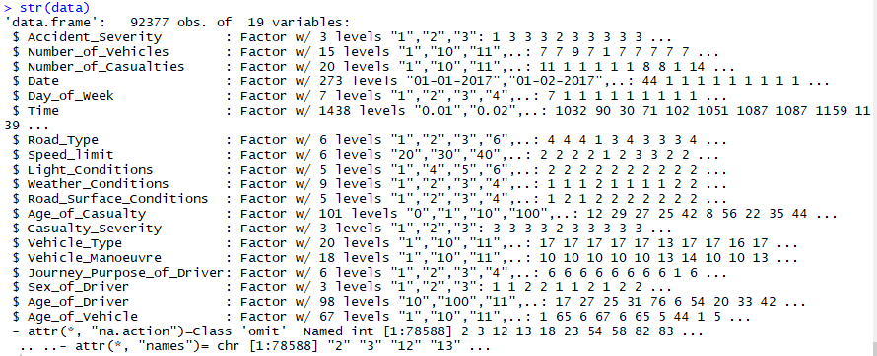
Figure 7: Structure of the dataset displaying the class of each variable

As shown in the above figure, several numerical variables such as number of vehicles, number of casualties, age of casualty, age of vehicle, etc. are incorrectly classified as factors. Including the date and time variable, which is incorrect. Hence, identifying the correct class of each variable and converting them into the appropriate class was conducted as shown in (figure 8) except for the ‘time’ variable, which will be treated in the next section.

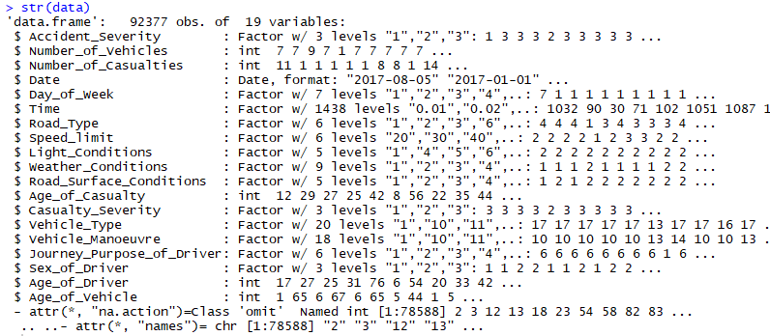
Figure 8: Structure of the dataset showing the appropriate class for each variable

4.2.4 Renaming the factor variables for better understanding:
As shown on figure 9, most of the factor variables have levels in numerical format. With the help of the data guide obtained from the repository (data.gov.uk, 2018), these levels were renamed to their appropriate labels for better understanding of the data (figure 9) during analysis/visualization phase.
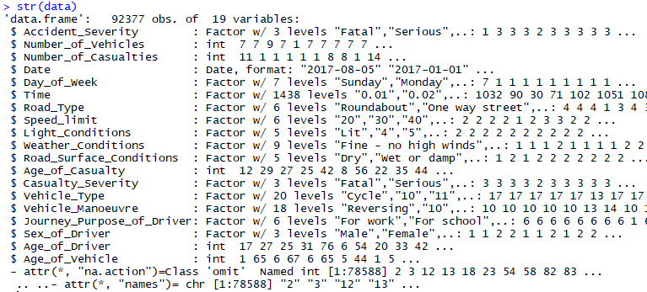
Figure 9: Structure of the dataset displaying the renamed levels of factor variables

4.2.5 Binning the factor variables:
Binning the levels in a factor variable involves in combining several levels into one for better data analysis and increasing the uniqueness of each level. The following levels of the variables are binned accordingly for an effective analysis,
- The ‘time’ variable consists of timestamps of the accident occurrence. In order to make this more meaningful and useful, the variable is converted into a factor variable containing 4 levels: ‘Morning (5-12)’, ‘Afternoon (12-17)’, ‘Evening (17-20)’, and ‘Night (20-5)’.
- The ‘light conditions’ with 5 levels were shrunk to 3 levels: ‘Lit’, ‘Dark’, ‘Unknown’.
- The ‘weather conditions’ with 9 levels were reduced to 8 levels: ‘Fine – no high winds’, ‘Rain – no high winds’, ‘Snow – no high winds’, ‘Fine – high winds’, ‘Rain – high winds’, ‘Snow – high winds’, ‘Fog/Mist’, ‘Other’.
- The ‘Vehicle type’ with 20 levels were way harder to interpret. Hence, they were reduced to 6 broad categories: ‘Cycle’, ‘Motorcycle’, ‘Car’, ‘Bus/Coach’, ‘Tram’, ‘Other’.
- The ‘Vehicle Manoeuvre’ with 18 levels were reduced to just 4 meaningful levels: ‘Reversing’, ‘Parked’, ‘Taking turn’, ‘Overtaking’.
- The variable, ‘Journey purpose of driver’ with 7 levels were reduced to 3 levels: ‘For work’, ‘For school’, ‘Other’.
- The variable, ‘Road surface conditions’ was categorized into 7 levels: ‘Dry’, ‘Wet/Damp’, ‘Snow’, ‘Frost/Ice’, ‘Flood (3cm. deep)’, ‘Oil/Diesel’, ‘Mud’.
- The variable, ‘Day of the week’ was simply classified into ‘Monday’, ‘Tuesday’, ‘Wednesday’, ‘Thursday’, ‘Friday’, ‘Saturday’, and ‘Sunday’.
- The variable, ‘Road type’ was classified into ‘Roundabout’, ‘One way street’, ‘Dual carriageway’, ‘Single carriageway’, ‘Slip road’, ‘Unknown’.
- The attribute, ‘Casualty severity’ is broadly classified into three main categories such as ‘Slight’, ‘Serious’, ‘Fatal’.
- The target variable, ‘Accident Severity’ consists of 3 levels: ‘Fatal’, ‘Severe’, ‘Slight’. However, the data is imbalanced as shown in (figure 10), as a result, the target variable is biased towards the class ‘Slight’ with 80% of data. Hence, the two levels ‘fatal’ and ‘severe’ are combined into one level as ‘High’, while the other majority class as ‘Low’.
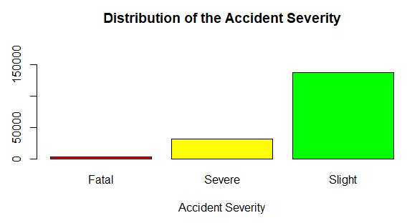
Figure 10: Distribution of the target variable
With the implementation of all the above-mentioned changes, the refined dataset’s structure is as follows (figure 11).
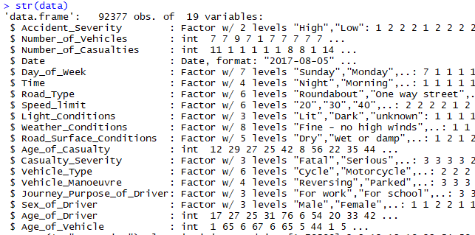
Figure 11: Structure of the refined dataset after binning the levels of factor variables
4.2.6 Handling of the imbalanced Dataset:
Despite the binning of the target variable to two classes, the data is still imbalanced. This affects the performance of the model by overfitting to the biased variable. Hence, it needs to be balanced. In order to tackle this situation, two techniques are practiced. The first technique involves in the combination of both oversampling and under-sampling the affected variable, while the second technique involves in ROSE (Random Over Sampling Examples). In the case of first technique about the combination of oversampling and under-sampling, the majority class is under-sampled, while the minority class is oversampled. Whereas, in ROSE (Random Over Sampling) technique, data is generated using the sampling and bootstrap approach. On comparison, the ROSE technique generates the data synthetically with higher accuracy than that of the combination of oversampling and under-sampling method. Hence, ROSE method is implemented for balancing the data. The ROSE method of handling an imbalanced dataset has answered the Objective C (Chapter 1, Section 1.3).
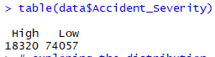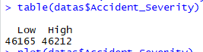
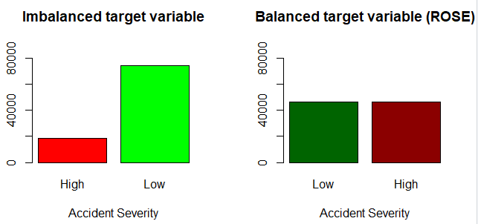
Figure 12: Comparison of the distribution of target variable after
the implementation of ROSE technique
(Figure 12) demonstrates the balancing of the target variable, ‘Accident Severity’ using the ROSE (Random Over Sampling) technique.
4.3 Data Exploration:
Data exploration is one of the stages where the data is analyzed and visualized using RapidMiner tool to be understood better before the data modelling stage. Distribution of all the attributes are analyzed here to understand the trends and patterns.
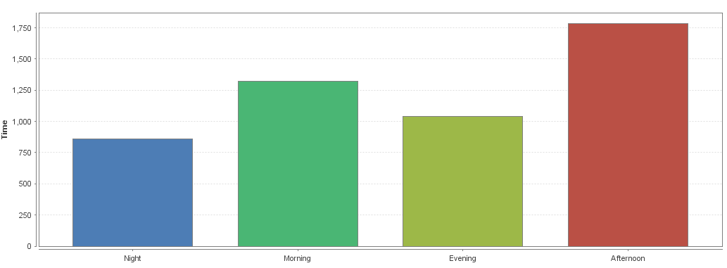
Figure 13: Distribution of the Time variable
(Figure 13) demonstrates the distribution of the time variable. On contrary to the idea that most of the accidents could have happened during night conditions, data shows that most of the accidents were happened during morning/afternoon under day light conditions.
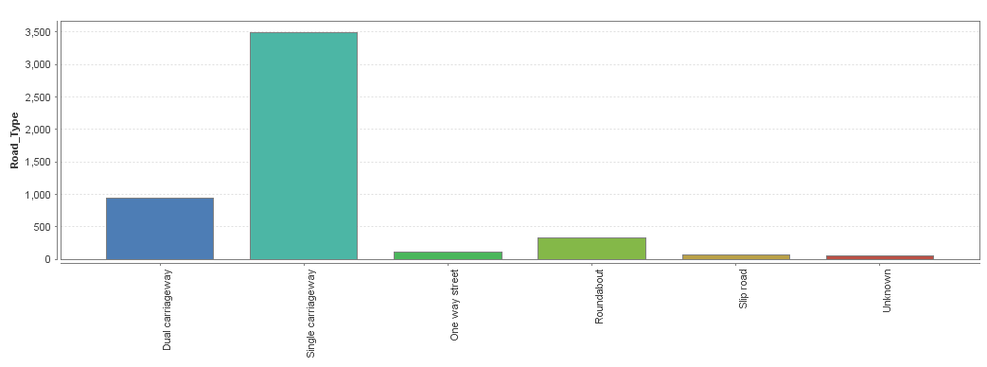
Figure 14: Distribution of road type
(Figure 14) demonstrates the accident occurrences based on road type. It is very evident from the data shown that most of the accidents have occurred on single carriageway road types. This could be due to the obvious reason of the absence of road intersections. Ranks second is the dual carriageway lane. One-way lanes seem to be far safe with very less occurrences of road traffic accidents.
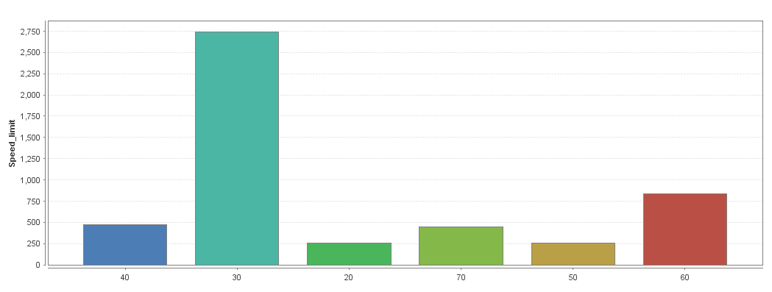
Figure 15: Distribution of speed limit
(Figure 15) demonstrates the accident occurrences that have happened in each speed limits set. It is evident from the chart that most of the accidents have happened in roads where the speed limit was supposed to be only 30 kmph. This raises the doubt that the accidents could have occurred on these roads due to over-speeding of the vehicles as 30 kmph is considered as a safe speed limit.
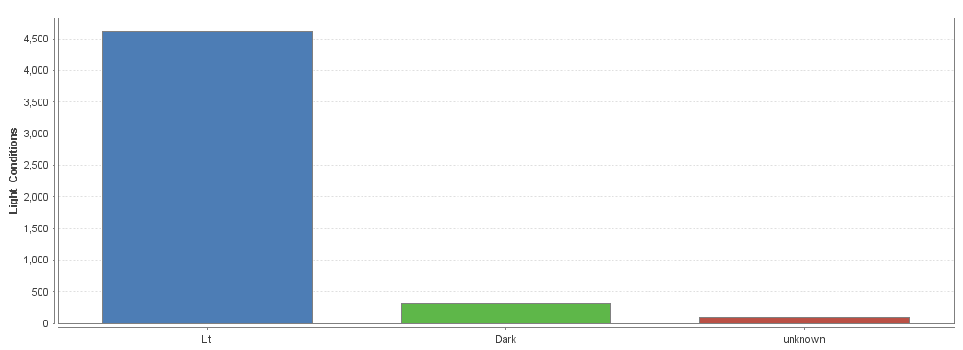
Figure 16: Distribution of light conditions
(Figure 16) demonstrates the accident occurrences under different light conditions. On contrary to the belief that accidents are most likely to happen during dark conditions, data shows that most of the accidents have happened in well-lit conditions. This begs the doubt that it could simply be because of the carelessness of the driver under broad light conditions.
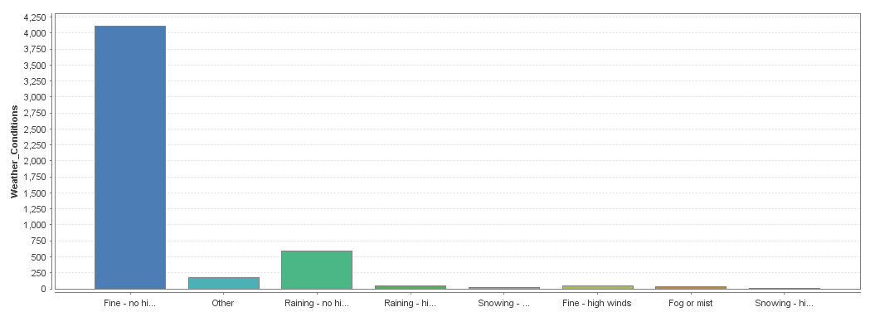
Figure 17: Distribution of weather conditions
(Figure 17) demonstrates the distribution of accidents occurred under different weather conditions. Similar to the patterns of light conditions and time of the day, the trend continues to follow as most of the accidents have happened in fine weather conditions with no high winds, compared to worse weather conditions such as high winds, rain, snow, etc.
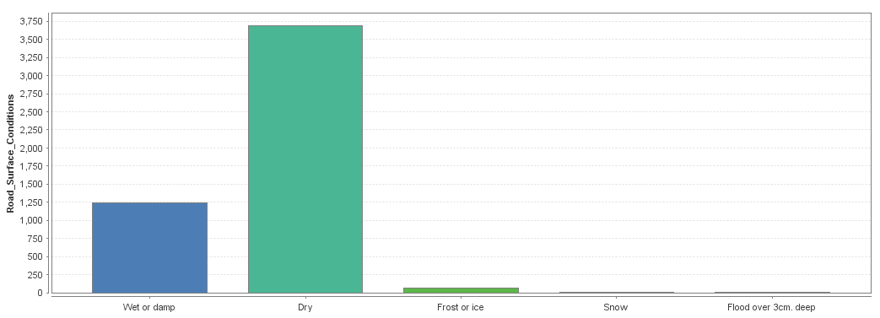
Figure 18: Distribution of road surface conditions
(Figure 18) demonstrates the road surface conditions on which accidents have occurred. Although most of the accidents have occurred in dry road conditions, a good amount of road accidents have happened in wet road conditions which lead to skidding of vehicles and in-turn causing accidents.

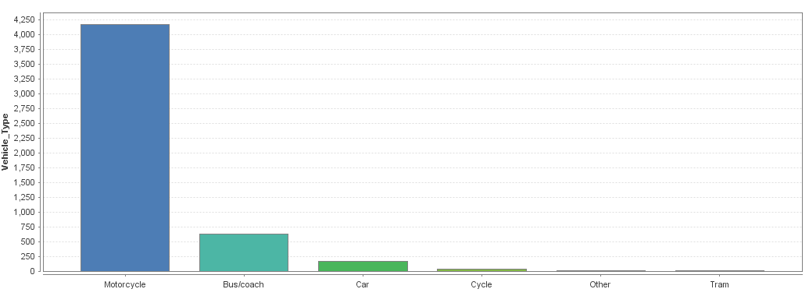
Figure 19: Distribution of vehicle type
(Figure 19) shows the type of vehicles that had involved in lots of accidents. Motorcycles ranks on top making it the dangerous type of vehicle as it provides less road safety to the driver compares to the other vehicle types. Ranks second is the buses/coaches which classify under the heavy motor vehicles that carry a lot of loads.
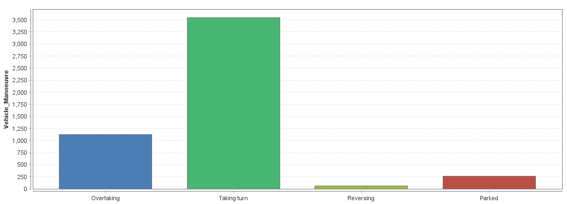
Figure 20: Distribution of vehicle maneuver
(Figure 20) shows on what circumstances most of the accidents have occurred. Data shows that most of the accidents have occurred while the vehicles were attempting to take a turn which puts the drivers in a vulnerable situation, followed by overtaking which is also a dangerous thing to attempt as it requires extreme caution by following the proper road safety rules.
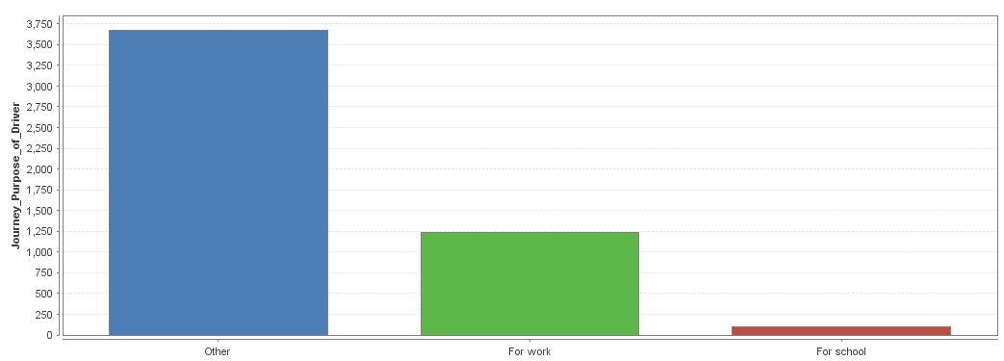
Figure 21: Distribution of journey purpose of driver
(Figure 21) displays on what occasions the accidents were more likely to happen. Although other is a broad category that ranks on top, ‘For work’ ranks second with a huge number of accidents. This begs the doubt that the drivers who are in a hurry to work tend to cause more accidents.
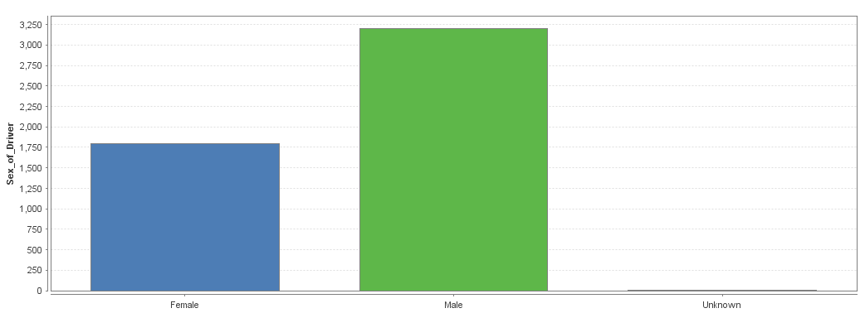
Figure 22: Distribution of gender
(Figure 22) shows that most of the accidents were happened by male compared to female. However, it’s hard to determine that males cause a lot of accidents as compared to females because of the absence of total population of both the genders who have travelled on those roads.

4.3.1 Removal of the variable ‘casualty severity’:
As demonstrated in (figure 23), the variable, casualty severity is highly correlated with the target variable accident severity. Since both these variables almost showcase the same values, modelling the data with the presence of casualty severity could cause the target variable to be biased on it ignoring the influence of other key factors. Besides, the severity of an accident or the casualty is most likely to be the same (95% relevance), thereby making the prediction of the target variable to be meaningless. From the (figure 23), it is seen that only in 4,625 cases of total 87,752 cases, the severity of the casualty is less on contrary to the high severity of the accident. With the absence of this variable, other key factors that determine the severity of the accident could be well studied. Hence, the variable ‘Casualty severity’ is removed from the dataset.
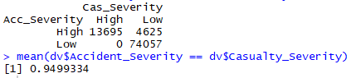
Figure 23: Table showing the relationship between the accident and casualty severity

4.4 Data Modelling:
Data modelling is the most important stage where a model is built with the help of the dataset in order to make predictions for given future value. In order to carry out this stage, five different classification algorithms such as decision tree, random forest, logistic regression, support vector machines and naive bayes are implemented to predict the severity of the road traffic accidents in Great Britain. The below section constitutes of implementation, evaluation and results of the built-models to predict the accident severity.
The metrics used to measure the performance of the algorithm will be accuracy, precision and recall. Following are the general formulas of the performance metrics:
Accuracy = (TP + TN) / (TP + TN + FP + FN) (1)
Accuracy is the ratio of correctly predicted observation to that of the total number of observations.
Precision = TP / (TP + FP) (2)
Precision is ratio of correctly predicted positive observations to that of the total predicted positive observations.
Recall = TP / (TP + FN) (3)
Recall is the ratio of correctly predicted positive observations to all the observations present in actual class
Here, TP = True Positive, TN = True Negative, FP = False Positive, and FN = False Negative.

4.4.1 Implementation, evaluation and results of Decision Tree:
Decision tree is the most commonly used classification approach for data mining. It is a supervised machine learning algorithm that can be used for classification of the data that consists of a set of values and it can be also be used for regression for continuous data, where it functions based on the standard deviation. Decision tree uses top down approach where the initial process starts at the root node. The root node consists of a condition based on which the tree is further divided into several branches. The nodes of each of these branches will further branch out based on some conditions until the tree reaches the leaf node. This determines the result for the input value. Decision tree also consists of different variants such as ID3, C4.5, CART etc.
Decision tree uses two major concepts for the implementation of the tree. They are entropy and information gain. Entropy is used to determine the homogeneity of the data. It states the level of randomness based on two values zero and one. If the value is zero, the data is totally homogeneous and if the value is one the data is uncertain (Mahajan & Kaur, 2016). Information gain is based on the reduction in entropy, if the variable in dataset consist of high information gain then it has best chances of variable splitting.
The formula for Entropy and Information gain is shown below (figure 24) (Priyanka & Sathiyakumari, 2014).
Figure 24: Information gain and Entropy
In this research project, the data is split in the ratio of 70:30, where the train dataset comprises of 70% of the whole dataset, while the test dataset comprises of the remaining 30%. With the help of ‘rpart’ library, the decision tree model is built in RStudio. Accident severity is considered as the dependent variable and the other variables in the dataset are considered as the independent variables. The decision tree is implemented based on the condition of accident severity. The leaf nodes of the tree will determine the output of the severity based on the different conditions. The confusion matrix is used to determine the accuracy, precision and recall metrics of the decision tree. The (figure 25) shows the confusion matrix table for the decision tree model. The precision metric is shown as Pos Pred value in confusion matrix while recall is shown as sensitivity in the confusion matrix. The decision tree has gained the Accuracy of 64.4%, precision of value 66% and recall of 61%. In addition, decision tree model has fulfilled part of the Objective D (Chapter 1, Section 1.3).
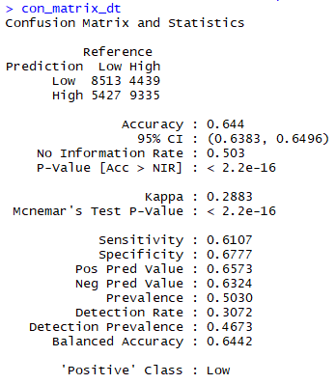
Figure 25: Confusion matrix of the decision tree model
4.4.2 Implementation, evaluation and results of Naïve Bayes:
Naïve Bayes works on the principal of probability by finding the class to which it belongs. It is a simple approach to perform classification of different classes. Performance of Naïve Bayes is more towards the supervised classification. The training dataset required for classification is small when compared to other models. Mostly naive bayes is used in text classification, accident analysis and anti-spam filtering (Patel & Mistry, 2015). Naïve bayes performs in two phases, the first phase is functional regarding the training data and the second phase is the classification of the model. The conditional probability formula used by the bayes theorem is as follows,

P(C_{k} | X) = P(C_{k}) . P(X | C_{k}) / P(X) (4)

In this research project, the ‘e1071’ package is used in RStudio to perform the naïve bayes modelling. Based on the conditional probability formula mentioned above, the model classifies the object in different classes. The accident severity is provided as the dependent variable using which the classification will be carried out. (figure 26) shows the confusion matrix of the built naive bayes model. The model has achieved Accuracy of 65.96%, while the precision achieved is 66% and recall is 66%. In addition, naive bayes model has fulfilled part of the Objective D (Chapter 1, Section 1.3).
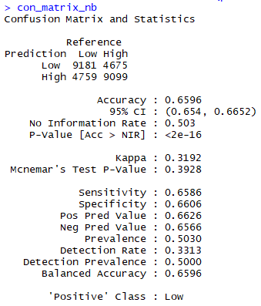
Figure 26: Confusion matrix of the Naïve Bayes model

4.4.3 Implementation, evaluation and results of Logistic Regression:
Logistic regression is a popularly used statistical model that is mainly used for supervised classification techniques. The model functions by predicting the dependent variable/target variable that’s a binary variable with two outcomes based on several independent variables that can either be numeric or categorical with classes. It functions with the help of logit function, where it possesses beta intercept and each variable’s respective beta coefficients. This GLM model of binomial family is implemented to compose a model that predicts the target variable ‘accident severity’ if it’s high or low based on the influence of the independent variables of the data.

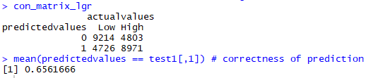
Figure 27: Confusion matrix of the logistic regression model

(Figure 27) shows that the built logistic regression model has achieved an accuracy of 65.61%, while the precision achieved is 65% and recall is 66%. In addition, logistic regression model has fulfilled part of the Objective D (Chapter 1, Section 1.3).

4.4.4 Implementation, evaluation and results of Support Vector Machines:
Support Vector Machines is also one of the supervised machine learning algorithms that is used for both classification analysis and regression analysis. However, it is widely used for classification purposes rather than regression. It functions by plotting all the datapoints in a multi-dimensional space. The number of dimensions for this space is determined by the number of attributes the dataset has. Then it involves in finding the hyper-plane between the plotted data points in the multi-dimensional area that separates two major classes on either side of the planes. The hyper plane that distinguishes the classes is termed as the support vector machine while the coordinates of it are termed as support vectors. Depending on the type of dataset, different kernels can be implemented for better efficiency of the model in finding the effective hyper plane. Kernels such as linear, radial, polynomial, etc. can be used to identify the perfect the hyper plane that gives the best accuracy.

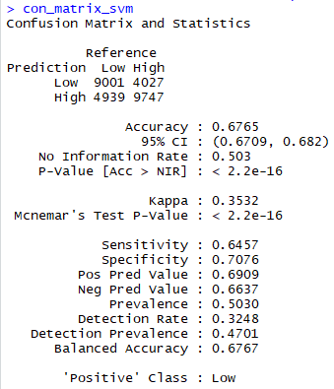
Figure 28: Confusion matrix of the support vector machines model

(Figure 28) shows that the built support vector machines (SVM) model has achieved an accuracy of 67.65%, while the precision achieved is 69% and recall is 65%. In addition, support vector machines model has fulfilled part of the Objective D (Chapter 1, Section 1.3).
4.4.5 Implementation, evaluation and results of Random Forest:
Random forest is a supervised machine learning algorithm used for both classification and regression. As the name suggests, the random forest consist of bunch of random trees combined together to produce accurate results. Random forest builds the tree by using multiple decision trees and uses bagging method to increase the accuracy of that tree. The working of random forest tree is in such a way that each tree in the forest votes for the classification of the new input and results of maximum votes for classification is considered as output for the forest (Datla, 2015). Hence if the forest is denser the results of prediction are also more accurate. The error rate of random forest depends on two cases, first the correlation between the trees and second the strength of the trees. The correlation is directly proportional to the error rate i.e. if correlation increases the error rate also increases and the strength is inversely proportional to the error rate i.e. if the error rate is low the strength is high. In this project, the random forest algorithm has been assigned with 500 trees. The accident severity is used as the dependent variable which will be used as the value upon which the tress in the forest will vote to perform classification.

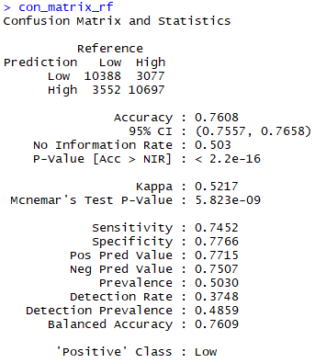
Figure 29: Confusion matrix of the random forest model.

The (figure 29) shows the confusion matrix for the built random forest model. The Accuracy achieved by this model is 76.08%, while the precision is 77% and recall is 75%. In addition, random forest model has fulfilled part of the Objective D (Chapter 1, Section 1.3).
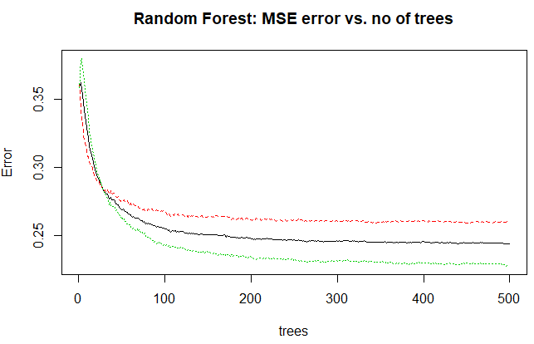
Figure 30: Comparison of error vs. the no. of trees.

(Figure 30) demonstrates how the error decreases with the increase in the no. of trees, post 300, the error rate becomes almost constant. Hence, the model was built with 500 trees although the dataset is large and takes longer computation time for the purpose of better prediction results.

4.4.5.1 Identifying the significant variables from random forest model:
The significance of each variable in the built model is identified using the random forest algorithm. The significance is identified based on the mean decrease in Gini coefficient. It is a measure of how every attribute adds to the homogeneity of the nodes and results in the subsequent random forest. Attributes that are significant possesses a higher mean decrease in Gini coefficient. (Figure 31) demonstrates the significance of each independent variable in the built random forest model.
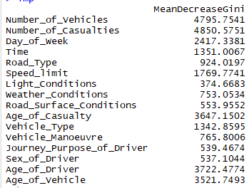
Figure 31: Importance of each variables based on mean decrease in Gini.

As per (figure 32), it is identified that apart from the last 4 variables, ‘Road surface conditions’, ‘Journey purpose of the driver’, ‘Sex of the driver’, and ‘Light conditions’, all the other variables have a mean decrease score of above 700. Hence these variables are identified to be significant for the model and are used as the only input variable for another model. This model is free of the contribution of the other 4 insignificant variables.
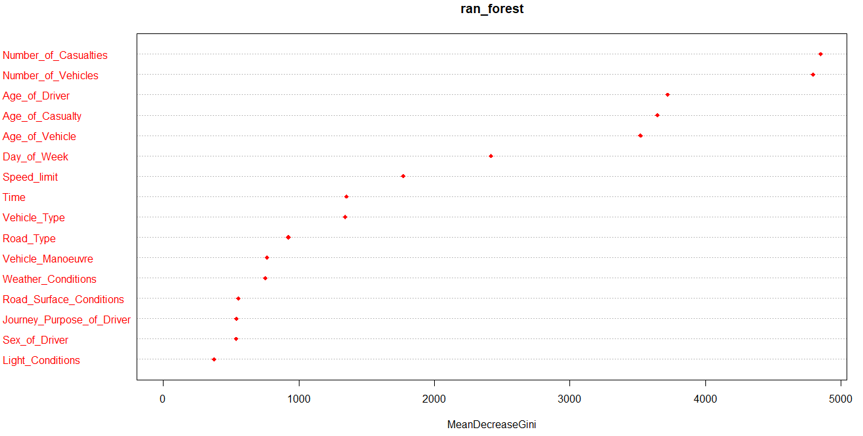
Figure 32: Significance of the variables plotted based on mean decrease in Gini

4.4.5.2 Implementation, evaluation, and results of the second random forest model with only the identified significant variables as input:
The identified significant variables are fed as the input variables to all the above-mentioned algorithms to see if it improves the accuracy of the existing models.
However, based on the results, it hardly made any difference to that of the existing models. While the accuracy dropped by 1 or 2% in algorithms like logistic regression, random forest, decision tree, etc. The accuracy was increased by a meagre 0.02% in Naïve Bayes model.
- Accuracy of the revised random forest model: 73.73% (2% decrease)
- Accuracy of the revised decision tree model: 64.4% (Same as above)
- Accuracy of the revised logistic regression model: 65.33% (0.3% decrease)
- Accuracy of the revised Naïve Bayes model: 65.98% (0.02% increase)
A revised model on support vector machines was not conducted due to the computation time of more than 30 minutes. Based on the above results, it has been noticed that the insignificant variables didn’t really affect the performance of the existing models as they neither affected the accuracy of the revised models in a positive or negative way, thereby not contributing much to the prediction of the dependent variable. This addressed the Objective E (Chapter 1, Section 1.3)

4.5 Data Evaluation:
In this phase, the models built in the data modelling stage are evaluated and compared against each other to determine the best prediction model for this study.

4.5.1 Evaluation based on the accuracy of each model:
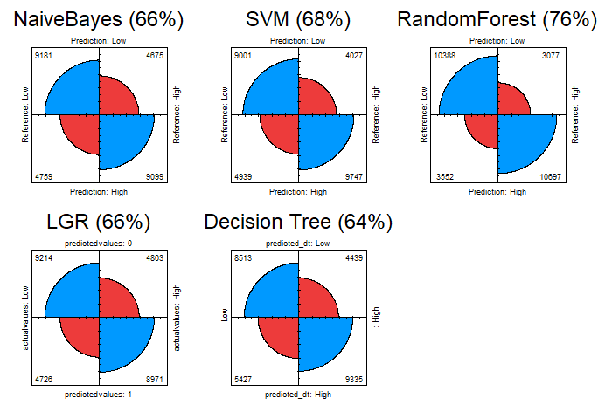
Figure 33: Fourfold plot - comparison of all the models based on accuracy

(Figure 33) showcases the fourfold plot of all the models, built based on their respective confusion matrices. Based on their accuracy, Random Forest model ranks on top with the highest accuracy of 76%, followed by Support Vector Machines model with an accuracy of 68%, followed by Naïve Bayes and Logistic Regression both ranking on the third spot with 66% of accuracy. Model with the least accuracy of all is the Decision Tree model with an accuracy of 64%.

4.5.2 Evaluation based on the ROC curve of each model:
A ROC (Receiver Operating Characteristic) curve is a graphical plot that is created by plotting the TP (True Positive) vs. the FP (False Positive). An efficient ROC curve should have high AUC (Area Under Curve) value. Higher the AUC value is, better the model is. (figure 34) showcases the ROC curves of the four models along with their AUC values. It is evident that the Random Forest’s ROC curve looks the best of all with highest AUC value of 0.838 than other models. The ROC curve for SVM model is not implemented due to computation time constraints.
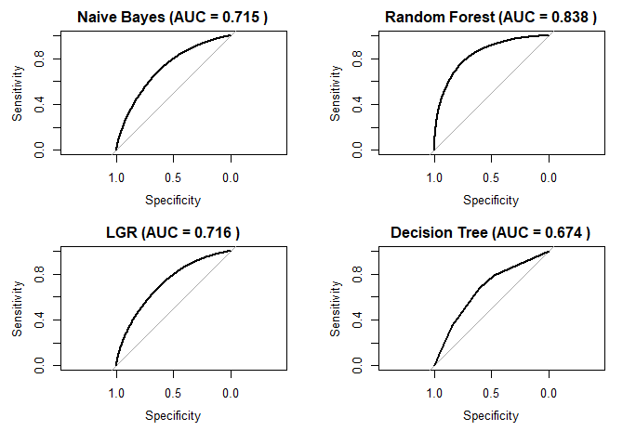
Figure 34: Comparison of ROC curves and AUC values of all the models

4.5.3 Comparison of the performance of models under various split ratios:
Data is split into train and test sets in the split ratios of 50:50, 60:40, 70:30, 80:20, 90:10 respectively. All these ratios are modelled, and their corresponding accuracy is plotted as shown in (figure 35). From the figure, it is evident that the 70:30 split ratio seems to be efficient split across all the models. Support Vector Machines was again not implemented here due to computational time limitations.
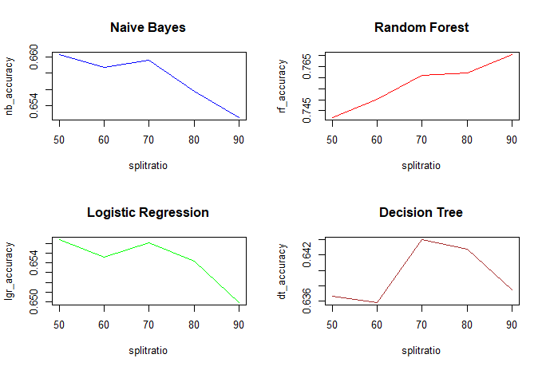
Figure 35: Comparison of performance of all the models under different split ratios

4.5.4 Summary:
Model | Accuracy (%) | Precision (%) | Recall (%) | AUC
Naïve Bayes | 65.96 | 66 | 66 | 0.715
Support Vector Machines | 67.65 | 69 | 65 | -
Random Forest | 76.08 | 77 | 75 | 0.838
Logistic Regression | 65.61 | 65 | 66 | 0.716
Decision Tree | 64.40 | 66 | 61 | 0.674
Table 2: Comparison of the derived results

(Table 2) showcases the comparison of all five models based on metrics such as their accuracy, precision, recall, and AUC values. It is clearly evident that Random Forest model excels in all the metrics making it the best model compared to all the other four models as it has achieved the highest metrics in all the categories, while Decision Tree has achieved the least values in all the metrics. This signifies that the accuracy of a model increases with the increase in no. of trees. In spite of the classes of the target variable, ‘Accident Severity’ being highly imbalanced, the models have performed reasonably well.

4.6 Data Visualization:
In this section, several combinations of different variables are compared with
one another and visualized using data visualization tool such as Tableau to find if they provide any interesting insights that can be used to lower the accidents occurrences or the severity of accidents in future.
Case 1: Effects of time of the day and light conditions on the accident severity.

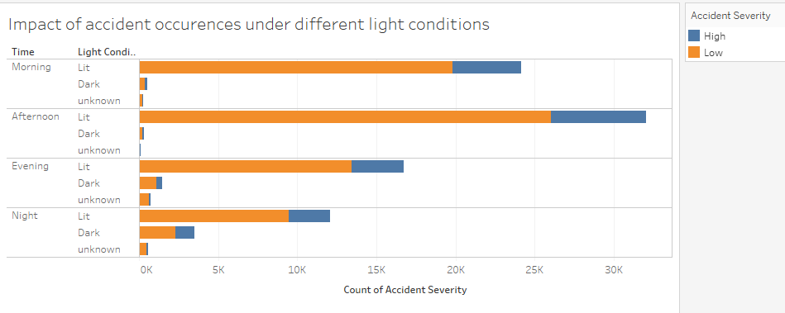
The above figure demonstrates the Count of Accidents for each Light Conditions broken down by Time. Color shows details about Accident Severity. On contrary to the belief that accidents are most likely to happen during night time or under dark conditions, data shows that most of the accidents have taken place in broad day lights and in well-lit conditions even during night time.

Case 2: Influence of weather and road conditions on severity of the accident
The below-figure demonstrates the count of accidents under different weather conditions broken down by road surface conditions. On contrary to the belief that accidents are most likely to happen in worse weather and road conditions, data shows that most of the accidents have taken place in fine weather conditions on dry roads. Followed by wet roads during rainy conditions.

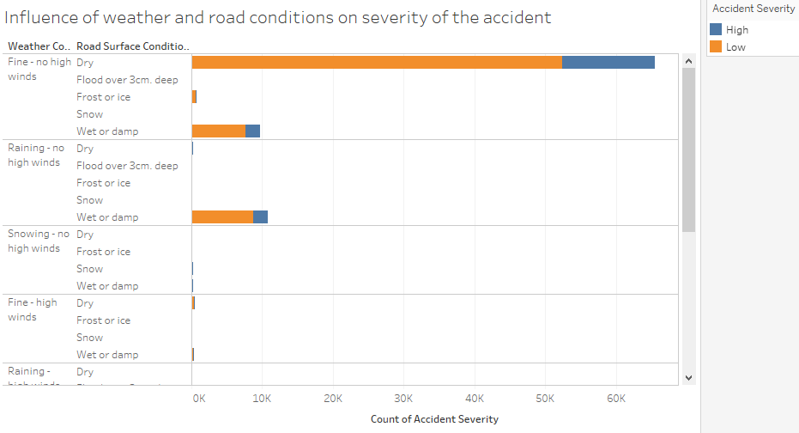

Case 3: Effect of weekdays and journey purpose on severity of the accidents.

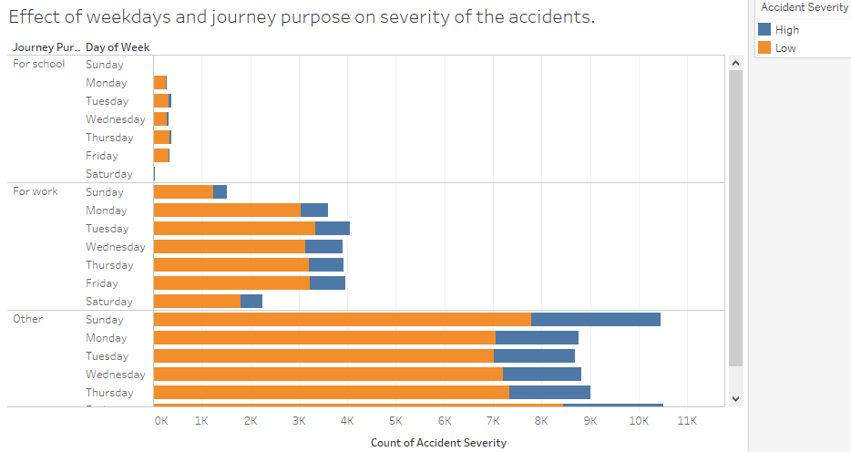
The above figure demonstrates the influence of journey purpose and day of the week on accident occurrences. Data showcases that most of the accidents had taken place under ‘other’ purposes which is vague. However, a substantial amount of accidents have taken place during weekdays by people who commute to work. This begs the doubt that office goers who are in a hurry to go to work cause a lot of accidents. Data also supports that most of the accidents have taken place in morning and afternoon which is the usual time when office goers travel.

Case 4: Effect of Vehicle and road types on accident severity
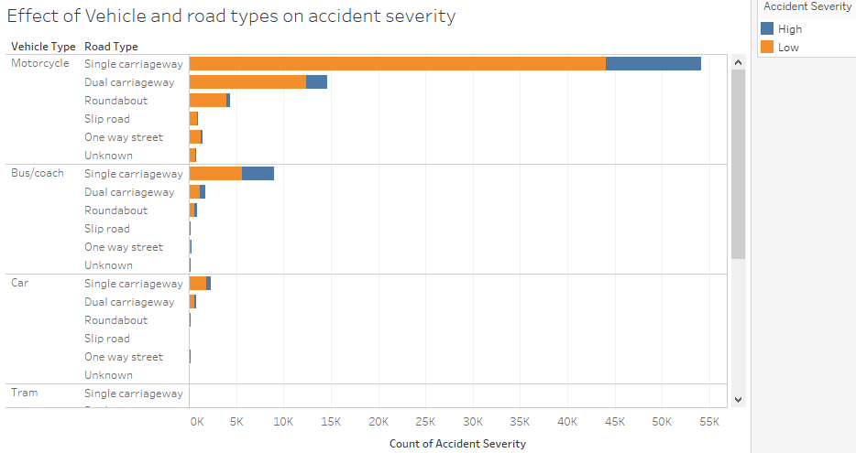
The above figure showcases the accident occurrences under different road types by vehicle types. Data shows that most of the accidents were caused by motorcyclists and especially on single carriageway lanes. This is evident with the absence of road intersections, people who travel on opposite lanes are more vulnerable to cause accidents.

Case 5: Effect of vehicle maneuvering by vehicles on road accidents
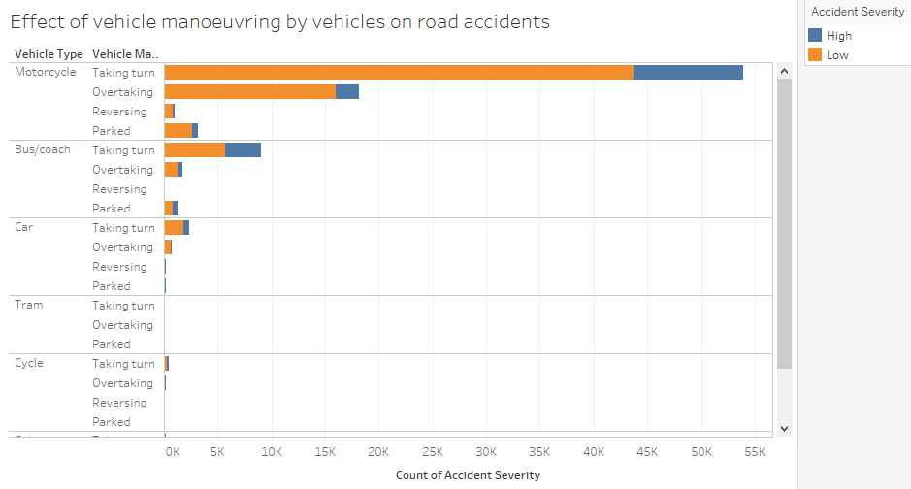
The above figure shows the effect of vehicle maneuvering by vehicle types on road accidents. While it is a known fact that most of the accidents were caused by motorcyclists, data shows that most of the accidents have taken place while taking turns or attempting to overtake other vehicles which needs to be done cautiously.
Case 6: Occurrences of accidents on different speed limits
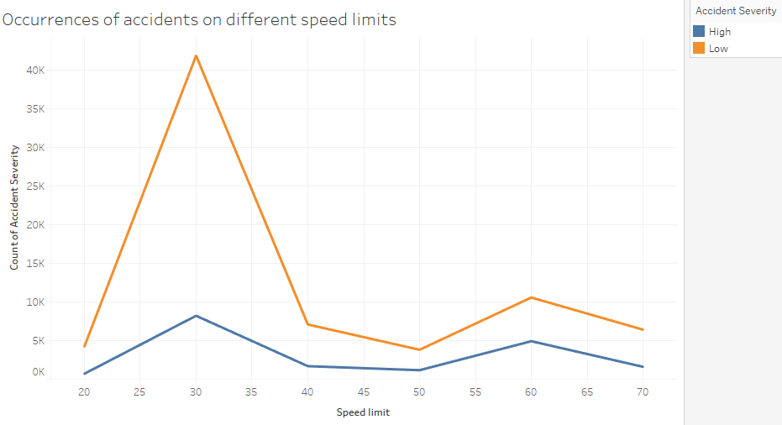

The above figure shows the count of accidents under different speed limit levels. The chart denotes that most of the accidents have taken place on roads under the speed limit of “30 kmph”. Speed limit is set to ‘30 kmph (slow speed limit)’ usually on roads that are accident prone or unsafe to drive fast. It begs the doubt that people could have attempted to drive past 30 kmph on these areas as 30 kmph is a very slow speed limit, thereby leading to road accidents.

Case 7: Impact of age of the drivers/casualties on road accidents

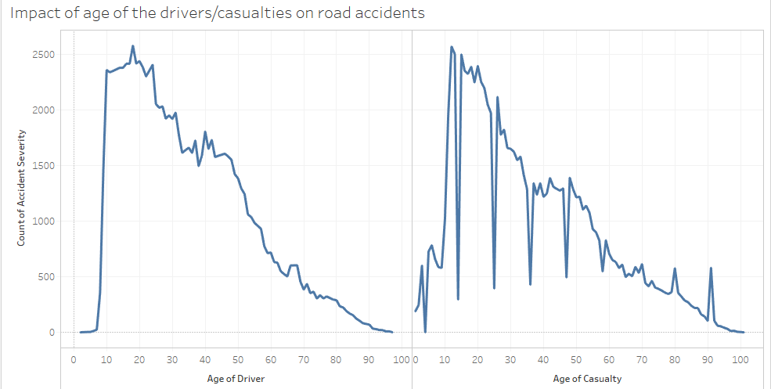

The above figure demonstrates the no. of accidents caused by each age category of the drivers/casualties. Both the charts show a similar curve due to the fact that the drivers are most likely to be the casualties on the road accidents. The charts clearly show that most of the accidents have been caused by the teenagers and youngsters as the curve peaks around the age band of 15-24. To be more precise, teenagers of age 18 have caused the most no. of accidents.

5. Conclusion and Future work:
The aim and objective of this research project was to predict the severity of the road traffic accidents in Great Britain. Several data mining techniques were handled and experimented to tackle the problem of determining the accident severity in Great Britain. The machine learning algorithms used for this study have provided good results and has addressed the research question (Chapter 1, Section 1.2). Starting with the data preparation, the missing values were treated and the numerous classes that were vague in each factor variables were treated to have meaningful classes for better data analysis using binning technique. Then the technique of Random Oversampling (ROSE) was implemented to handle the imbalanced dataset as it could lead to biased predictions and incorrect results. Doing so had boosted the performance of the models and provided efficient accuracy results. Due to the imbalance in the target variable among the three classes, two of the classes were merged into one for better balancing of the data. The identified gaps in the literatures (Chapter 2, Section 2.5) were addressed and implemented on the research project to yield effective prediction results. Under data exploration, behaviours and patterns of each of the variables were studied for effective data modelling. It provided interesting insights about the occurrences of accidents. It was observed that most of the accidents had occurred during the daytime or well-lit conditions on dry/wet roads when the weather was totally fine with no high winds. It was also observed that vehicles that accounted for most of the accidents were motorcycles and people who accounted for most of these accidents were office goers. Several classification models were built to make effective prediction of the target variable. It was observed that the Random Forest technique performed the best among all the other models with an accuracy of 76%. The models developed in (Chapter 4, Section 4.4) are believed to be a significant contribution for the data analytics community to demonstrate the ways on dealing with large and imbalanced datasets. Based on the work done in this research project, the candidate proposes a future work to determine the accidents hotpots and find out the severity of those hotspots which in turn could help the concerned officials in increasing the safety measures to reduce the accident occurrences in such areas. In addition, the candidate also proposes to experiment the implementation of more data mining techniques to improve the prediction accuracy of the road traffic accidents, which were not carried out in this research study due to the limited time frame.

6. References
Achmad, H., Sabur, V. F., Pritasari, A. & Reinaldo, H., 2016. Data mining and sharing to create usable knowledge, implementation in small business in Indonesia. Sains Humanika, Volume 8, pp. 1-2.
Ahlawat, A. & Suri, B., 2016. Improving classification in data mining using hybrid algorithm. Information Processing (IICIP), 2016 1st India International Conference on IEEE, pp. 1-4.
Anderson, T. K., 2009. Kernel density estimation and k-means clustering to profile road accident hotspots. Accident Analysis & Prevention, 41(3), pp. 359-364.
Atnafu, B. & Kaur, G., 2017. Survey on analysis and prediction of road traffic accident severity levels using data mining techniques in Maharashtra, India. International Journal of Current Engineering and Technology, 7(6), pp. 1973-1978.
Beshah, T. & Hill, S., 2010. Mining road traffic accident data to improve safety: Role of road-related factors on accident severity in ethiopia. AAAI Spring Symposium: Artificial Intelligence for Development..
Chong, M., Abraham, A. & Paprzycki, M., 2005. Traffic accident analysis using machine learning paradigms. Informatica, 29(1).
data.gov.uk, 2018. Road Safety Data. [Online]
Available at: https://data.gov.uk/dataset/053a6529-6c8c-42ac-ae1e-455b2708e535/road-traffic-accidents
Datla, M. V., 2015. Bench marking of classification algorithms: Decision trees and random forests - a case study using r. Trends in Automation, Communications and Computing Technology (I-TACT-15), 2015 International Conference on, IEEE, pp. 1-7.
Esmaeili, A., Khalili, M. & Pakgohar, A., 2012. Determining the road defects impact on accident severity; based on vehicle situation after accident, an approach of logistic regression. Statistics in Science, Business, and Engineering (ICSSBE), 2012 International Conference on, IEEE, pp. 1-4.
Ghomi, H., Fu, L., Bagheri, M. & Miranda-Moreno, L. F., 2017. Identifying vehicle driver injury severity factors at highway-railway grade crossings using data mining algorithms. Transportation Information and Safety (ICTIS), 2017 4th International Conference on, IEEE, pp. 1054-1059.
Gopalakrishnan, S., 2012. A Public Health Perspective of Road Traffic Accidents. Journal of family medicine and primary care, 1(2), p. 144.
Huang, K., 2017. Field Support Vector Machines. IEEE Transactions on Emerging Topics in Computational Intelligence ( Volume: 1 , Issue: 6 ), pp. 454-463.
Jackson, L. & Cracknell, R., 2018. Road accident casualties in Britain and the world. House of Commons Library, p. 6.
Kabeer, S. I., 2016. Analysis of road accident in leeds. p. 12.
Kashani, A. T. & Mohaymany, A. S., 2011. Safety Science, 49(10), pp. 1314-1320.
Li, L., Shrestha, S. & Hu, G., 2017. Analysis of road traffic fatal accidents using data mining techniques. Software Engineering Research, Management and Applications (SERA), 2017 IEEE 15th International Conference on, IEEE, pp. 363-370.
Mahajan, N. & Kaur, B. P., 2016. International Journal of Computer Applications (0975-8887) volume.
Patel, K., 2010. Lowering the barrier to applying machine learning. Adjunct proceedings of the 23nd annual ACM symposium on User interface software and technology, ACM, pp. 355-358.
Patel, P. & Mistry, K., 2015. A review: Text classification on social media data. IOSR Journal of Computer Engineering, 17(1), pp. 80-84.
Priyanka, A. & Sathiyakumari, K., 2014. A comparative study of classiffication algorithm using accident data. International Journal of Computer Science & Engineering Technology (IJCSET), 5(10), pp. 1018-1023.
Quddus, M. A., Wang, C. & Ison, S. G., 2009. Road traffic congestion and crash severity: econometric analysis using ordered response models. Journal of Transportation Engineering, 136(5), pp. 424-435.
Shanthi, S. & Ramani, R. G., 2012. Feature relevance analysis and classification of road traffic accident data through data mining techniques. Proceedings of the World Congress on Engineering and Computer Science, Volume 1, pp. 24-26.
Tavakoli Kashani, A., Shariat-Mohaymany, A. & Ranjbari, A., 2011. A data mining approach to identify key factors of traffic injury severity. PROMET - Traffic & Transportation, 23(1), pp. 11-17.
Tesema, T. B., Abraham, A. & Grosan, C., 2005. Rule mining and classification of road traffic accidents using adaptive regression trees. International Journal of Simulation , 6(10), pp. 80-94.
Theofilatos, A., Graham, D. & Yannis, G., 2012. Factors affecting accident severity inside and outside urban areas in greece. Traffic injury prevention, 13(5), pp. 458-467.
Tian, R., Yang, Z. & Zhang, M., 2010. Method of road traffic accidents causes analysis based on data mining. Computational Intelligence and Software Engineering (CiSE), 2010 International Conference on, IEEE, pp. 1-4.
Vorko-Jovic, A., Kern, J. & Biloglav, Z., 2006. Risk factors in urban road traffic accidents. Journal of Safety Research, 37(1), pp. 93-98.
Yannis, G., Golias, J. & Papadimitriou, E., 2005. Driver age and vehicle engine size effects on fault and severity in young motorcyclists accidents. Accident Analysis & Prevention, 37(2), pp. 327-333.
Zekić-Sušac, M., Šarlija, N., Has, A. & Bilandžić, A., 2016. Predicting company growth using logistic regression and neural networks. Croatian Operational Research Review, p. 236.
Zhang, G., Yau, K. K. & Chen, G., 2013. Risk factors associated with traffic violations and accident severity in china. Accident Analysis & Prevention, Volume 59, pp. 18-25.
Zong, F., Xu, H. & Zhang, H., 2013. Prediction for traffic accident severity: comparing the bayesian network and regression models. Mathematical Problems in Engineering.

7. Appendix
This section comprises of the R codes used for this research study.
1. Merging the datasets:
# loading all the individual datasets
acc <- read.csv(file.choose())
cas <- read.csv(file.choose())
veh <- read.csv(file.choose())

# viewing the datasets
View(acc)
View(cas)
View(veh)

# merging the first two datasets
datam <- merge(acc, cas)

# merging the merged dataset with the third dataset
dataset <- merge(data1, veh)

# viewing the final version of the merged dataset
View(dataset)

# exporting the merged dataset
write.csv(dataset, file = "dataset.csv")

2. Data preparation:
# loading the mergeddata
data1 <- read.csv(file.choose())
View(data1)
str(data1)

# checking the dimensions of the data
dim(data1)

# checking for missing values
sum(is.na(data1))

# removing the missing values
data2 <- na.omit(data1)

# checking if the missing values have been removed
sum(is.na(data2))

# removing the unwanted variables
data3 <- data2[,c(8:13,18:19,26:28,37,39,48,50,59:61,65)]
View(data3)

# replacing the "-1" instances with NA
data4 <- data.frame(lapply(data3, function(x) {
gsub(-1, NA, x)
}))
View(data4)

# checking the no. of observations that has missing values
table(is.na(data4))

# removing missing values as it accounts for only 1% of data
data <- na.omit(data4)

# checking the dimensions of the refined data
table(is.na(data))
dim(data)
str(data)
View(data)

# changing the class of certain variables
data[,2] <- as.integer(data$Number_of_Vehicles)
data[,3] <- as.integer(data$Number_of_Casualties)
data[,12] <- as.integer(data$Age_of_Casualty)
data[,18] <- as.integer(data$Age_of_Driver)
data[,19] <- as.integer(data$Age_of_Vehicle)
str(data)

# renaming the factor variables for better understanding
library(plyr)
data$Accident_Severity <- revalue(data$Accident_Severity, c('1'='Fatal','2'='Serious','3'='Slight'))
data$Day_of_Week <- revalue(data$Day_of_Week, c('1'='Sunday','2'='Monday','3'='Tuesday',
'4'='Wednesday','5'='Thursday','6'='Friday','7'='Saturday'))
data$Casualty_Severity <- revalue(data$Casualty_Severity, c('1'='Fatal','2'='Serious','3'='Slight'))
data$Sex_of_Driver <- revalue(data$Sex_of_Driver, c('1'='Male','2'='Female','3'='Unknown'))
str(data)

# binning the time variable into 4 parts
time <- as.character(data$Time)
data[,6] <- as.numeric(time)
data$Time <- cut(data$Time, c(0,5,12,17,20,24),
labels=c('Night1','Morning','Afternoon','Evening','Night2'))

# grouping the night1 and 2 into one level
levels(data$Time) <- c('Night','Morning','Afternoon','Evening','Night')
levels(data$Time)

str(data)

# exploring the distribution of target variable
levels(data4$Accident_Severity) <- c("Fatal", "Severe", "Slight")
levels(data4$Accident_Severity)

plot(data4$Accident_Severity, xlab = 'Accident Severity',
col = c('red','yellow','green'), ylim = c(0,180000),
main = 'Distribution of the Accident Severity')
table(data4$Accident_Severity)

# target variable is imbalanced. grouping the levels into high and low
levels(data$Accident_Severity)
levels(data$Accident_Severity) <- c("High", "High", "Low")
levels(data$Accident_Severity)

levels(data$Light_Conditions)
levels(data$Light_Conditions) <- c("1", "1", "2",'2','3')
levels(data$Light_Conditions)

levels(data$Weather_Conditions)
levels(data$Weather_Conditions) <- c("1", "2", "3",'4','5','6','7','8','8')
levels(data$Weather_Conditions)

levels(data$Vehicle_Type)
levels(data$Vehicle_Type) <- c('1','2','2','2','2','3','3','4','4','1','3','5','4','4','4','2','2','6','2','4')
levels(data$Vehicle_Type)

levels(data$Vehicle_Manoeuvre)
levels(data$Vehicle_Manoeuvre) <- c('1','2','2','2','2','3','3','3','3','3','3','3','4','4','4','4','4','4')
levels(data$Vehicle_Manoeuvre)

levels(data$Journey_Purpose_of_Driver)
levels(data$Journey_Purpose_of_Driver) <- c('1','1','2','2','3','3','3')
levels(data$Journey_Purpose_of_Driver)

##############################################

# handling the date variable. (with date variable)
data$Date <- as.Date(data$Date, "%d-%m-%Y")
str(data)

#############################################

# renaming the other factor variables

data$Road_Type <- revalue(data$Road_Type, c('1'='Roundabout','2'='One way street',
'3'='Dual carriageway','6'='Single carriageway','7'='Slip road','9'='Unknown'))

data$Light_Conditions <- revalue(data$Light_Conditions, c('1'='Lit','2'='Dark','3'='unknown'))

data$Weather_Conditions <- revalue(data$Weather_Conditions, c('1'='Fine - no high winds','2'='Raining - no high winds',
'3'='Snowing - no high winds','4'='Fine - high winds','5'='Raining - high winds','6'='Snowing - high winds',
'7'='Fog or mist','8'='Other'))

data$Road_Surface_Conditions <- revalue(data$Road_Surface_Conditions, c('1'='Dry','2'='Wet or damp',
'3'='Snow','4'='Frost or ice','5'='Flood over 3cm. deep','6'='Oil or diesel',
'7'='Mud'))

data$Journey_Purpose_of_Driver <- revalue(data$Journey_Purpose_of_Driver, c('1'='For work','2'='For school',
'3'='Other'))

data$Vehicle_Type <- revalue(data$Vehicle_Type, c('1'='Cycle','2'='Motorcycle','3'='Car','4'='Bus/coach','5'='Tram','6'='Other'))

data$Vehicle_Manoeuvre <- revalue(data$Vehicle_Manoeuvre, c('1'='Reversing','2'='Parked','3'='Taking turn','4'='Overtaking'))

#############################################

# removing the date variable for data modeling
data <- data[,-4]
str(data)

###############################################

# still there's an imbalance, hence we do random over sampling

install.packages('ROSE')
library(ROSE) # installing the required package

datas <- ROSE(Accident_Severity ~ ., data = data, seed=1)$data

View(datas)
table(datas$Accident_Severity)
plot(datas$Accident_Severity)
str(datas)

# exporting the data
write.csv(datas, file = "datas.csv")

###############################################

# comparison of distribution

par(mfrow = c(1,2))

plot(data$Accident_Severity, xlab = 'Accident Severity',
col = c('red','green'), ylim = c(0,90000),
main = 'Imbalanced target variable')

plot(datas$Accident_Severity, xlab = 'Accident Severity',
col = c('dark green','dark red'), ylim = c(0,90000),
main = 'Balanced target variable (ROSE)')

###############################################

3. Data modelling:
# Data modelling
dv <- data

levels(dv$Casualty_Severity)
levels(dv$Casualty_Severity) <- c('High','High','Low')
levels(dv$Casualty_Severity)

t <- table(Acc_Severity = dv$Accident_Severity, Cas_Severity = dv$Casualty_Severity)

plot(dv$Accident_Severity)
plot(dv$Casualty_Severity)

mean(dv$Accident_Severity == dv$Casualty_Severity)

prop.table(t)

dt <- datas[,-12] # removal of casualty severity because of strong correlation
set.seed(170283) # for the consistency
str(dt)

#splitting the dataset in 70:30 ratio
nrows <- nrow(dt)
index <- sample(1:nrows, 0.7 * nrows) # shuffle and divide
train <- dt[index,]
test <- dt[-index,]

# checking the dimensions after the split
dim(data)
dim(train)
dim(test)

prop.table(table(train$Accident_Severity)) # checking for the proportion
prop.table(table(test$Accident_Severity))

# (1) Naive Bayes:

library(e1071)
library(caret)

# fitting the model
naiveb <- naiveBayes(train[,-1], train$Accident_Severity)

# predicting test set with the trained model
predicted_nb <- predict(naiveb, test[,-1],type = 'class')

# confusion matrix to see the performance
con_matrix_nb <- confusionMatrix(predicted_nb, test$Accident_Severity)
con_matrix_nb

# (2) SVM:

# fitting the model
svm <- svm(Accident_Severity~., data=train)

# predicting test set with the trained model
predicted_svm <- predict(svm, test[,-1])

# confusion matrix to see the performance
con_matrix_svm <- confusionMatrix(predicted_svm, test$Accident_Severity)
con_matrix_svm

# (3) Random Forest:

library(randomForest)
str(data)
str(train)
str(test)

# fitting the model
ran_forest <- randomForest(Accident_Severity~., data=train, ntree=500)

# identifying the importance of variables based on Mean Decrease
imp <- importance(ran_forest)

# checking the importance of variables
varImpPlot(ran_forest,pch=18,col='red',cex=1)

# performance of random forest model
plot(ran_forest, main="Random Forest: MSE error vs. no of trees")

# predicting test set with the trained model
predicted_rf <- predict(ran_forest, test[,-1])

# confusion matrix to see the performance
con_matrix_rf <- confusionMatrix(predicted_rf, test$Accident_Severity)
con_matrix_rf

# (4) LGR:

lgr <- glm(Accident_Severity ~.,train, family="binomial")
summary(lgr)

res <- predict(lgr, test, type="response") # prediction

dim(test)
predictedvalues = rep(0,27714)
predictedvalues[res>0.5] = 1

con_matrix_lgr <- table(predictedvalues,actualvalues=test[,1])

test1 <- test
test1$Accident_Severity <- revalue(test1$Accident_Severity,
c('High'='1','Low'='0'))
mean(predictedvalues == test1[,1]) # correctness of prediction

# (5) decision tree:

library(rpart)

detree <- rpart(Accident_Severity~.,train,method='class')
plot(detree)
text(detree,pretty = 0)
summary(detree)

predicted_dt <- predict(detree,test,type = 'class')
con_matrix_dt <- confusionMatrix(predicted_dt,test$Accident_Severity)

cfdt <- table(predicted_dt,test$Accident_Severity)

#################################################################

4. Chaining algorithms with random forest

library(randomForest)

# identifying the importance of variables based on Mean Decrease
imp <- importance(ran_forest)

# checking the importance of variables
varImpPlot(ran_forest,pch=18,col='red',cex=1)

################################################################
# (3.1) Rf model with only significant variables

str(train) # checking the variables to be removed based on Importance
str(test)

train1 <- train[,c(-8,-10,-14,-15)] # removing the insignificant variables
test1 <- test[,c(-8,-10,-14,-15)]

str(train1) # checking if the variables have been removed correctly
str(test1)

# building the rf model with the new trainset
ran_forest_1 <- randomForest(Accident_Severity~., data=train1, ntree=500)

# performance of the new random forest model
plot(ran_forest_1, main="Random Forest 1: MSE error vs. no of trees")

# predicting the new test set with the new trained model
predicted_rf_1 <- predict(ran_forest_1, test1[,-1])

# confusion matrix to see the performance
con_matrix_rf_1 <- confusionMatrix(predicted_rf_1, test1$Accident_Severity)
con_matrix_rf_1

################################################################

# (1) fitting the model
nb1 <- naiveBayes(train1[,-1], train1$Accident_Severity)

# predicting test set with the trained model
predicted_nb_1 <- predict(nb1, test1[,-1])

# confusion matrix to see the performance
con_matrix_nb_1 <- confusionMatrix(predicted_nb_1, test1$Accident_Severity)
con_matrix_nb_1

###############################################################

# (2) decision tree:
library(rpart)
detree1 <- rpart(Accident_Severity~.,train1,method='class')

predicted_dt_1 <- predict(detree1,test1,type = 'class')
con_matrix_dt_1 <- confusionMatrix(predicted_dt_1,test1$Accident_Severity)
con_matrix_dt_1

#####################################################################

# (3) LGR

lgr1 <- glm(Accident_Severity ~.,train1, family="binomial")
summary(lgr1)

res1 <- predict(lgr1, test1, type="response") # prediction

dim(test1)
predictedvalues1 = rep(0,27714)
predictedvalues1[res1>0.5] = 1

con_matrix_lgr_1 <- table(predictedvalues1,actualvalues=test1[,1])

test2 <- test1
test2$Accident_Severity <- revalue(test2$Accident_Severity,
c('High'='1','Low'='0'))
mean(predictedvalues1 == test2[,1]) # correctness of prediction

#####################################################################

5. Data evaluation:
# comparison of all the models based on accuracy

col <- c("#ed3b3b", "#0099ff")
par(mfrow=c(2,3))

fourfoldplot(con_matrix_nb$table, color = col, conf.level = 0,
margin = 1, main=paste("NaiveBayes (",round(con_matrix_nb$overall[1]*100),"%)",sep=""))

fourfoldplot(con_matrix_svm$table, color = col, conf.level = 0,
margin = 1, main=paste("SVM (",round(con_matrix_svm$overall[1]*100),"%)",sep=""))

fourfoldplot(con_matrix_rf$table, color = col, conf.level = 0,
margin = 1, main=paste("RandomForest (",round(con_matrix_rf$overall[1]*100),"%)",sep=""))

fourfoldplot(con_matrix_lgr, color = col, conf.level = 0,
margin = 1, main=paste("LGR (",round(mean(predictedvalues == test1[,1])*100),"%)",sep=""))

fourfoldplot(cfdt, color = col, conf.level = 0,
margin = 1, main=paste("Decision Tree (",round(con_matrix_dt$overall[1]*100),"%)",sep=""))

######################################################################

# comparison of all the models based on roc curve

install.packages('pROC')
library(pROC) # package required for plotting the roc curve

par(mfrow=c(2,2))

# (1) NB:

predicted_nb1 <- predict(naiveb, test, type = 'raw')

auc1 <- auc(test$Accident_Severity,predicted_nb1[,2])
plot(roc(test$Accident_Severity,predicted_nb1[,2]),
main=paste('Naive Bayes (AUC =', round(auc1, digits = 3),')'), sep = '')

# (2) RF:

predicted_rf1 <- predict(ran_forest, test, type = 'prob')

auc3 <- auc(test$Accident_Severity,predicted_rf1[,2])
plot(roc(test$Accident_Severity,predicted_rf1[,2]),
main=paste('Random Forest (AUC =', round(auc3, digits = 3),')'), sep = '')

# (3) LGR:

predicted_lgr1 <- predict(lgr, test, type = 'response')

auc4 <- auc(test$Accident_Severity,predicted_lgr1)
plot(roc(test$Accident_Severity,predicted_lgr1),
main=paste('LGR (AUC =', round(auc4, digits = 3),')'), sep = '')

# (4) DT:

predicted_dt1 <- predict(detree,test,type = 'prob')

auc5 <- auc(test$Accident_Severity,predicted_dt1[,2])
plot(roc(test$Accident_Severity,predicted_dt1[,2]),
main=paste('Decision Tree (AUC =', round(auc5, digits = 3),')'), sep = '')

###################################################################

6. Comparison of different split ratios

library(e1071)
library(caret)
library(randomForest)
library(rpart)

# 50% ---------------------------------------------------------------

dt50 <- dt
set.seed(170283) # for the consistency
str(dt50)

#splitting the dataset
nrows50 <- nrow(dt50)
index50 <- sample(1:nrows50, 0.5 * nrows50) # shuffle and divide
train50 <- dt50[index50,]
test50 <- dt50[-index50,]

# checking the dimensions after the split
dim(dt50)
dim(train50)
dim(test50)

prop.table(table(train50$Accident_Severity))
prop.table(table(test50$Accident_Severity))

# (1) Naive Bayes:

# fitting the model
naiveb50 <- naiveBayes(train50[,-1], train50$Accident_Severity)

# predicting test set with the trained model
predicted_nb50 <- predict(naiveb50, test50[,-1])

# confusion matrix to see the performance
con_matrix_nb50 <- confusionMatrix(predicted_nb50, test50$Accident_Severity)
con_matrix_nb50 # Acc: 0.6603

# (2) Random Forest:

# fitting the model
ran_forest50 <- randomForest(Accident_Severity~., data=train50, ntree=300)

# predicting test set with the trained model
predicted_rf50 <- predict(ran_forest50, test50[,-1])

# confusion matrix to see the performance
con_matrix_rf50 <- confusionMatrix(predicted_rf50, test50$Accident_Severity)
con_matrix_rf50 # Acc: 0.7419

# (3) LGR:

lgr50 <- glm(Accident_Severity ~.,train50, family="binomial")

res50 <- predict(lgr50, test50, type="response") # prediction

dim(test50)
predictedvalues50 = rep(0,46189)
predictedvalues50[res50>0.5] = 1

con_matrix_lgr50 <- table(predictedvalues50,actualvalues=test50[,1])

tests50 <- test50
tests50$Accident_Severity <- revalue(tests50$Accident_Severity,
c('High'='1','Low'='0'))
mean(predictedvalues50 == tests50[,1]) # correctness of prediction
# Acc: 0.6564

# (4) DT:

detree50 <- rpart(Accident_Severity~.,train50,method='class')

predicted_dt50 <- predict(detree50,test50,type = 'class')
con_matrix_dt50 <- confusionMatrix(predicted_dt50,test50$Accident_Severity)
con_matrix_dt50 # Acc: 0.6366

# 60% ---------------------------------------------------------------

dt60 <- dt
set.seed(170283) # for the consistency
str(dt60)

#splitting the dataset
nrows60 <- nrow(dt60)
index60 <- sample(1:nrows60, 0.6 * nrows60) # shuffle and divide
train60 <- dt60[index60,]
test60 <- dt60[-index60,]

# checking the dimensions after the split
dim(dt60)
dim(train60)
dim(test60)

prop.table(table(train60$Accident_Severity))
prop.table(table(test60$Accident_Severity))

# (1) Naive Bayes:

# fitting the model
naiveb60 <- naiveBayes(train60[,-1], train60$Accident_Severity)

# predicting test set with the trained model
predicted_nb60 <- predict(naiveb60, test60[,-1])

# confusion matrix to see the performance
con_matrix_nb60 <- confusionMatrix(predicted_nb60, test60$Accident_Severity)
con_matrix_nb60 # Acc: 0.6587

# (2) Random Forest:

# fitting the model
ran_forest60 <- randomForest(Accident_Severity~., data=train60, ntree=300)

# predicting test set with the trained model
predicted_rf60 <- predict(ran_forest60, test60[,-1])

# confusion matrix to see the performance
con_matrix_rf60 <- confusionMatrix(predicted_rf60, test60$Accident_Severity)
con_matrix_rf60 # Acc: 0.7503

# (3) LGR:

lgr60 <- glm(Accident_Severity ~.,train60, family="binomial")

res60 <- predict(lgr60, test60, type="response") # prediction

dim(test60)
predictedvalues60 = rep(0,36951)
predictedvalues60[res60>0.5] = 1

con_matrix_lgr60 <- table(predictedvalues60,actualvalues=test60[,1])

tests60 <- test60
tests60$Accident_Severity <- revalue(tests60$Accident_Severity,
c('High'='1','Low'='0'))
mean(predictedvalues60 == tests60[,1]) # correctness of prediction
# Acc: 0.6546

# (4) DT:

detree60 <- rpart(Accident_Severity~.,train60,method='class')

predicted_dt60 <- predict(detree60,test60,type = 'class')
con_matrix_dt60 <- confusionMatrix(predicted_dt60,test60$Accident_Severity)
con_matrix_dt60 # Acc: 0.6358

# 70% ---------------------------------------------------------------

# NB: 0.6596
# RF: 0.7608
# LGR: 0.6561
# DT: 0.6440

# results obtained from existing models

# 80% ---------------------------------------------------------------

dt80 <- dt
set.seed(170283) # for the consistency
str(dt80)

#splitting the dataset
nrows80 <- nrow(dt80)
index80 <- sample(1:nrows80, 0.8 * nrows80) # shuffle and divide
train80 <- dt80[index80,]
test80 <- dt80[-index80,]

# checking the dimensions after the split
dim(dt80)
dim(train80)
dim(test80)

prop.table(table(train80$Accident_Severity))
prop.table(table(test80$Accident_Severity))

# (1) Naive Bayes:

# fitting the model
naiveb80 <- naiveBayes(train80[,-1], train80$Accident_Severity)

# predicting test set with the trained model
predicted_nb80 <- predict(naiveb80, test80[,-1])

# confusion matrix to see the performance
con_matrix_nb80 <- confusionMatrix(predicted_nb80, test80$Accident_Severity)
con_matrix_nb80 # Acc: 0.6558

# (2) Random Forest:

# fitting the model
ran_forest80 <- randomForest(Accident_Severity~., data=train80, ntree=300)

# predicting test set with the trained model
predicted_rf80 <- predict(ran_forest80, test80[,-1])

# confusion matrix to see the performance
con_matrix_rf80 <- confusionMatrix(predicted_rf80, test80$Accident_Severity)
con_matrix_rf80 # Acc: 0.7621

# (3) LGR:

lgr80 <- glm(Accident_Severity ~.,train80, family="binomial")

res80 <- predict(lgr80, test80, type="response") # prediction

dim(test80)
predictedvalues80 = rep(0,18476)
predictedvalues80[res80>0.5] = 1

con_matrix_lgr80 <- table(predictedvalues80,actualvalues=test80[,1])

tests80 <- test80
tests80$Accident_Severity <- revalue(tests80$Accident_Severity,
c('High'='1','Low'='0'))
mean(predictedvalues80 == tests80[,1]) # correctness of prediction
# Acc: 0.6542

# (4) DT:

detree80 <- rpart(Accident_Severity~., train80, method='class')

predicted_dt80 <- predict(detree80,test80,type = 'class')
con_matrix_dt80 <- confusionMatrix(predicted_dt80,test80$Accident_Severity)
con_matrix_dt80 # Acc: 0.6428

# 90% ---------------------------------------------------------------

dt90 <- dt
set.seed(170283) # for the consistency
str(dt90)

#splitting the dataset
nrows90 <- nrow(dt90)
index90 <- sample(1:nrows90, 0.9 * nrows90) # shuffle and divide
train90 <- dt90[index90,]
test90 <- dt90[-index90,]

# checking the dimensions after the split
dim(dt90)
dim(train90)
dim(test90)

prop.table(table(train90$Accident_Severity))
prop.table(table(test90$Accident_Severity))

# (1) Naive Bayes:

# fitting the model
naiveb90 <- naiveBayes(train90[,-1], train90$Accident_Severity)

# predicting test set with the trained model
predicted_nb90 <- predict(naiveb90, test90[,-1])

# confusion matrix to see the performance
con_matrix_nb90 <- confusionMatrix(predicted_nb90, test90$Accident_Severity)
con_matrix_nb90 # Acc: 0.6525

# (2) Random Forest:

# fitting the model
ran_forest90 <- randomForest(Accident_Severity~., data=train90, ntree=300)

# predicting test set with the trained model
predicted_rf90 <- predict(ran_forest90, test90[,-1])

# confusion matrix to see the performance
con_matrix_rf90 <- confusionMatrix(predicted_rf90, test90$Accident_Severity)
con_matrix_rf90 # Acc: 0.7703

# (3) LGR:

lgr90 <- glm(Accident_Severity ~.,train90, family="binomial")

res90 <- predict(lgr90, test90, type="response") # prediction

dim(test90)
predictedvalues90 = rep(0,9238)
predictedvalues90[res90>0.5] = 1

con_matrix_lgr90 <- table(predictedvalues90,actualvalues=test90[,1])

tests90 <- test90
tests90$Accident_Severity <- revalue(tests90$Accident_Severity,
c('High'='1','Low'='0'))
mean(predictedvalues90 == tests90[,1]) # correctness of prediction
# Acc: 0.6499

# (4) DT:

detree90 <- rpart(Accident_Severity~., train90, method='class')

predicted_dt90 <- predict(detree90,test90,type = 'class')
con_matrix_dt90 <- confusionMatrix(predicted_dt90,test90$Accident_Severity)
con_matrix_dt90 # Acc: 0.6375

######################################################################

# plotting the trend

nb_accuracy <- c(0.6603,0.6587,0.6596,0.6558,0.6525)
rf_accuracy <- c(0.7419,0.7503,0.7608,0.7621,0.7703)
lgr_accuracy <- c(0.6564,0.6546,0.6561,0.6542,0.6499)
dt_accuracy <- c(0.6366, 0.6358,0.6440,0.6428,0.6375)
splitratio <- c(50,60,70,80,90)

par(mfrow=c(2,2))

plot(splitratio, nb_accuracy, type='l',col='blue',main = 'Naive Bayes')
plot(splitratio, rf_accuracy, type='l',col='red',main='Random Forest')
plot(splitratio, lgr_accuracy, type='l',col='green',main='Logistic Regression')
plot(splitratio, dt_accuracy, type='l',col='brown',main = 'Decision Tree')

################################################

